|  |  |
| --- | --- |
| Capgemini_logo_hr_TIF |  |

Leave Management System (LMS) - USA

Master Functional Document

Version: 3.0

Date: Nov 2016

Table of Contents

[1. Basic Flow/Functionality 3](#_Toc463517990)

[1.1 Existing Functionality 3](#_Toc463517991)

[1.2 Change in Functionality 3](#_Toc463517992)

[2. Functional Solution proposed 4](#_Toc463517993)

[2.1 Functional flow: 4](#_Toc463517994)

[2.2 LMS and its features: 4](#_Toc463517995)

[Menu 4](#_Toc463517996)

[Home Page Screen🡪Employee 5](#_Toc463517997)

[Home Page Screen🡪Admin 6](#_Toc463517998)

[Home Page🡪Supervisor 7](#_Toc463517999)

[Leave accrual 8](#_Toc463518000)

[Leave Credit job for US 10](#_Toc463518001)

[Carryover & Forfeiture 11](#_Toc463518002)

[Dashboard 12](#_Toc463518003)

[Leave Management >> Apply Leave 13](#_Toc463518004)

[Leave Management >> View/Cancel Leave 30](#_Toc463518005)

[Approvals >> Approve Leave 33](#_Toc463518006)

[Approvals >> Delegate LMS Approver 38](#_Toc463518007)

[Approvals >> Acknowledge Approver Delegation 40](#_Toc463518008)

[Admin >> Manage Holiday List 42](#_Toc463518009)

[Admin >> Rollover / Forfeiture Extension 43](#_Toc463518010)

[Admin >> Update Disability Schedule 45](#_Toc463518011)

[Admin >> ADP Schedule Payment 47](#_Toc463518012)

[Reports >> View Holiday List 48](#_Toc463518013)

[Reports >> Leave Details 48](#_Toc463518014)

[Reports >> Unpaid Payroll Report For US 51](#_Toc463518015)

[Reports >> Unpaid Disability Payroll Report For US 52](#_Toc463518016)

[Admin >> Role Management 53](#_Toc463518017)

[Business Rules 55](#_Toc463518018)

[3. Screen Shots 56](#_Toc463518019)

[4. Field Validation 57](#_Toc463518020)

[5. Cross Field Validation 58](#_Toc463518021)

[6. Messages 59](#_Toc463518022)

| REVISION HISTORY | |
| --- | --- |
| **DOCUMENT NAME** | Functional Specifications |
| **ABSTRACT** |  |
| **SECURITY CLASSIFICATION** | Company Confidential |
| **LOCATION** | iQ |
| **iQ VERSION NO:** | 1.6 Issue |

| AUTHORISATION | | |
| --- | --- | --- |
| **Document Owner** | **Reviewed By** | **Authorized By** |
| Alethea Richard | Kunal Pankaj | Liz Cauffman |

|  |  |  |  |  |  |
| --- | --- | --- | --- | --- | --- |
| **AMENDMENT LOG** | | | | | |
| **Version** | **Date DD MM YYYY** | **Section** | **Source of Change** | **A/M/D** | **Brief Description of Change** |
| 1.0 | Sept 2016 |  |  | A | Version 1.0 is created |
| 2.0 | Sept 2016 |  |  | M | Version 2.0  Added additional features as per 2017 policy chanfew |
| 2.1 | Oct 2016 |  |  | M | Version 2.1  Added validation and additional information  Email templates  Role Management  Leave details Report |
| 3.0 | Nov 2016 |  |  | A & M | Added: Exception Offer (on confirmation from Liz)  Modify: |
|  |  |  |  |  |  |
|  |  |  |  |  |  |
|  |  |  |  |  |  |
|  |  |  |  |  |  |
|  |  |  |  |  |  |

# Basic Flow/Functionality

## Existing Functionality

Current flow of US LMS

* Bi-monthly leave credit basis tenure and designation of employee
* Employee applies leave in LMS
* Post approval from Supervisor and/or HR the leave plan is available in Clarity
* Employee submits timesheet in Clarity
* Post approval from PM the actual leave information is pushed back to LMS
* The leave information and balance information available in leave card of employee is based on the information received from Clarity.

## Change in Functionality

|  |  |
| --- | --- |
| 1. **Current Features for US HR Admin, Role Admin, ADP Reports** | 1. **Mapping in New LMS** |
| View Leave Card | Reports >> Leave Details |
| Apply Leave | Leave Management >> Apply Leave |
| View/Modify Planned Leave | Leave Management >> View / Cancel Leave |
| View Holiday List | Reports >> View Holiday List |
| View Employee Leave Calendar | This is not included in new LMS design, as the employee, his direct reportees leave details would be available in Reports >> Leave Details |
| View Employee Weekly Leave Calendar  Bottom of Form | This is not included in new LMS design, as the employee, his direct reportees leave details would be available in Reports >> Leave Details |
| Top of Form  Approval for Leave Plan  Bottom of Form | Approvals >> Approve Leave |
| Update Disability Schedule | Admin >> Update Disability Schedule |
| Delegate LMS Approver | Approvals >> Delegate LMS Approver |
| Acknowledge LMS Approver Delegation | Approvals >> Acknowledge Approver Delegation |
| Holiday List Approval  Bottom of Form | Need confirmation if this is required, as the Holiday list is managed by US HR  This is not required 🡪 confirmed by Liz |
| Top of Form  Role Management  Bottom of Form | Admin >> Role Management |
| Manage Holiday List | Admin >> Manage Holiday List |
| Rollover/Forfeiture extension | Admin >> Rollover/Forfeiture extension |
| Exceptional Offers | Need confirmation if this is required, as there is not much data available through this form  This is required 🡪 confirmed by Liz |
| Apply For Leave By HR Admin  Bottom of Form | Leave Management >> Apply Leave --> there would be an check box for HR Admin view |
| Leave Balance Report For Self/Team | This is not included in new LMS design, as the employee, his direct reportees leave details would be available in Reports >> Leave Details |
| Actual Leave Taken Report for Self/Team | This is not included in new LMS design, as the employee, his direct reportees leave details would be available in Reports >> Leave Details |
| Planned Leave Balance Report for Self/Team | This is not included in new LMS design, as the employee, his direct reportees leave details would be available in Reports >> Leave Details |
| Current/Projected Leave Balance Report | This is not included in new LMS design, as the employee, his direct reportees leave details would be available in Reports >> Leave Details |
| Leave Pending For Approval Report | This is not included in new LMS design, as the employee, his direct reportees leave details would be available in Reports >> Leave Details |
| Actual Leave Taken Report For Admin | This is not included in new LMS design, as the employee, his direct reportees leave details would be available in Reports >> Leave Details |
| Leave Plan Details Report | This is not included in new LMS design, as the employee, his direct reportees leave details would be available in Reports >> Leave Details |
| Actual Leave Taken Report for US Admin | This is not included in new LMS design, as the employee, his direct reportees leave details would be available in Reports >> Leave Details |
| Comp Off Leave Taken Report For Self/Team | Not valid |
| Leave Taken Report For ADP | Not required as per input from Krishna Laad |
| Leave Accrual Report For ADP | Not required as per input from Krishna Laad |
| Unpaid Payroll Report For US | Reports >> Unpaid Payroll Report For US |
| Historical Data Report | Not required as per input from Krishna Laad |
| Unpaid Disability Payroll Report For US | Reports >> Unpaid Disability Payroll Report For US |

# Functional Solution proposed

## Functional flow:

1. Leave entry for current plus 6 months will be done in LMS.
2. As soon as employee has applied leave, the leave balance would be deducted by that number of leaves.
3. The information would be available in Clarity for employee to fill timesheet post the leave is approved in LMS.
4. Employee would be able to submit timesheet only if the Supervisor and/or HR has approved the leave application in LMS.
5. No leave information would be pulled back from clarity.
6. No leave can be directly applied in Clarity.
7. For sabbatical, family medical leave of absence, personal leave of absence, bereavement, jury duty, military leave, short/long term disability and illness/sick leaves front end will allow user to upload details/documents. Once uploaded and approval from supervisor/people process is received, Clarity will then be able enable the codes for time entry.

## LMS and its features:

### Menu

* Dashboard
* Leave Management
  + Apply Leave
  + View/Cancel Leave
* Approvals
  + Approve Leave
  + Delegate LMS Approver
  + Acknowledge LMS Approver Delegation
* Reports
  + View Holiday List
  + Leave Details 🡪 format copied from India LMS implementations
  + [Unpaid Payroll Report For US](javascript:__doPostBack('ctl00$mnuMainMenu','Reports\\Unpaid%20Payroll%20Report%20For%20US'))
  + [Unpaid Disability Payroll Report For US](javascript:__doPostBack('ctl00$mnuMainMenu','Reports\\Unpaid%20Disability%20Payroll%20Report%20For%20US'))
* Admin
  + Role Management
  + [ADP Payment Schedule](javascript:__doPostBack('ctl00$mnuMainMenu','Admin%20screens\\%20ADP%20Payment%20Schedule'))
  + [Update Disability Schedule](javascript:__doPostBack('ctl00$mnuMainMenu','Pending%20Approvals\\\\Update%20Disability%20Schedule'))
  + Exception Offer

### Home Page Screen🡪Employee

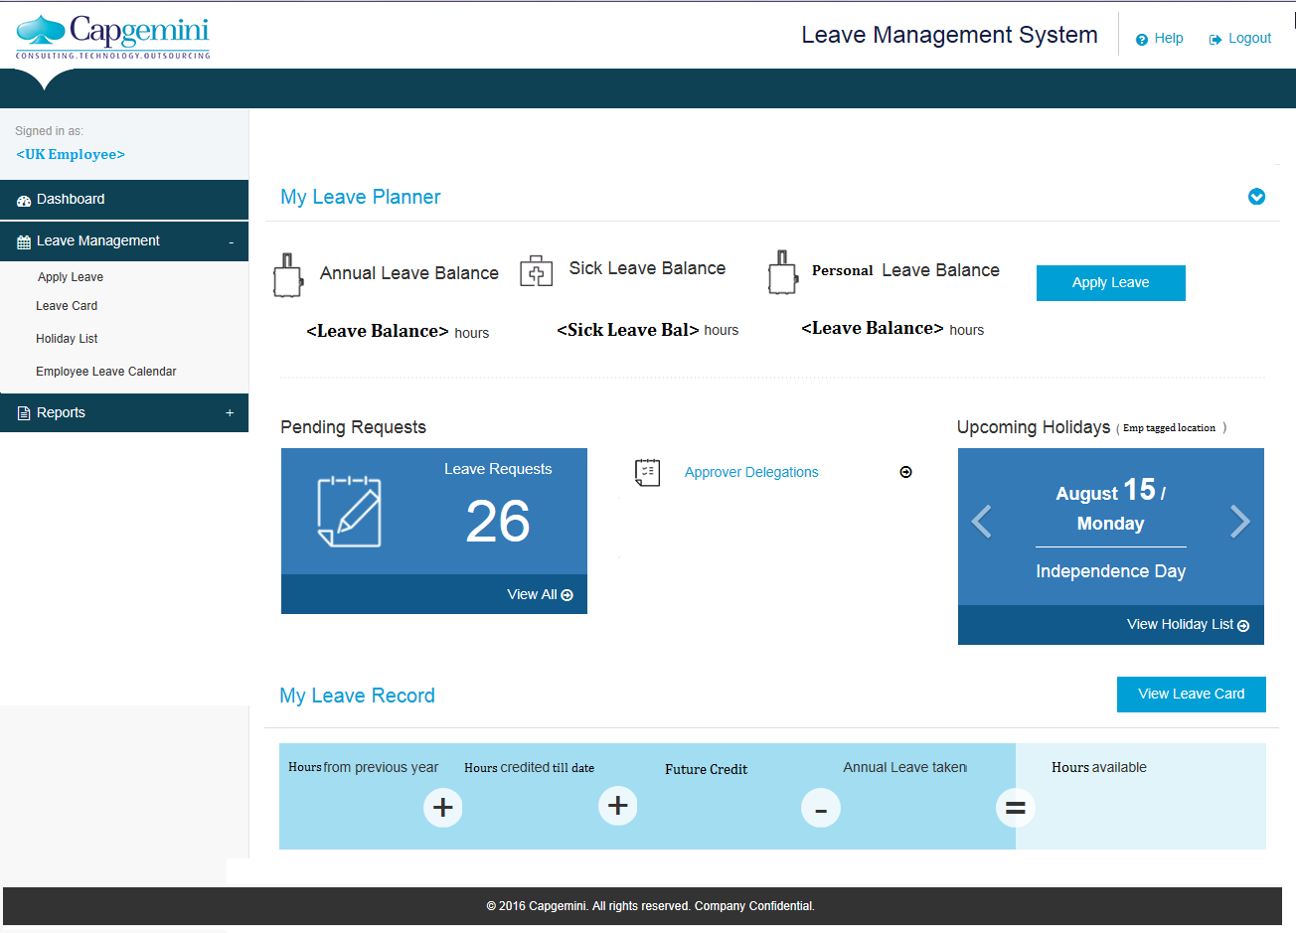

### Home Page Screen🡪Admin

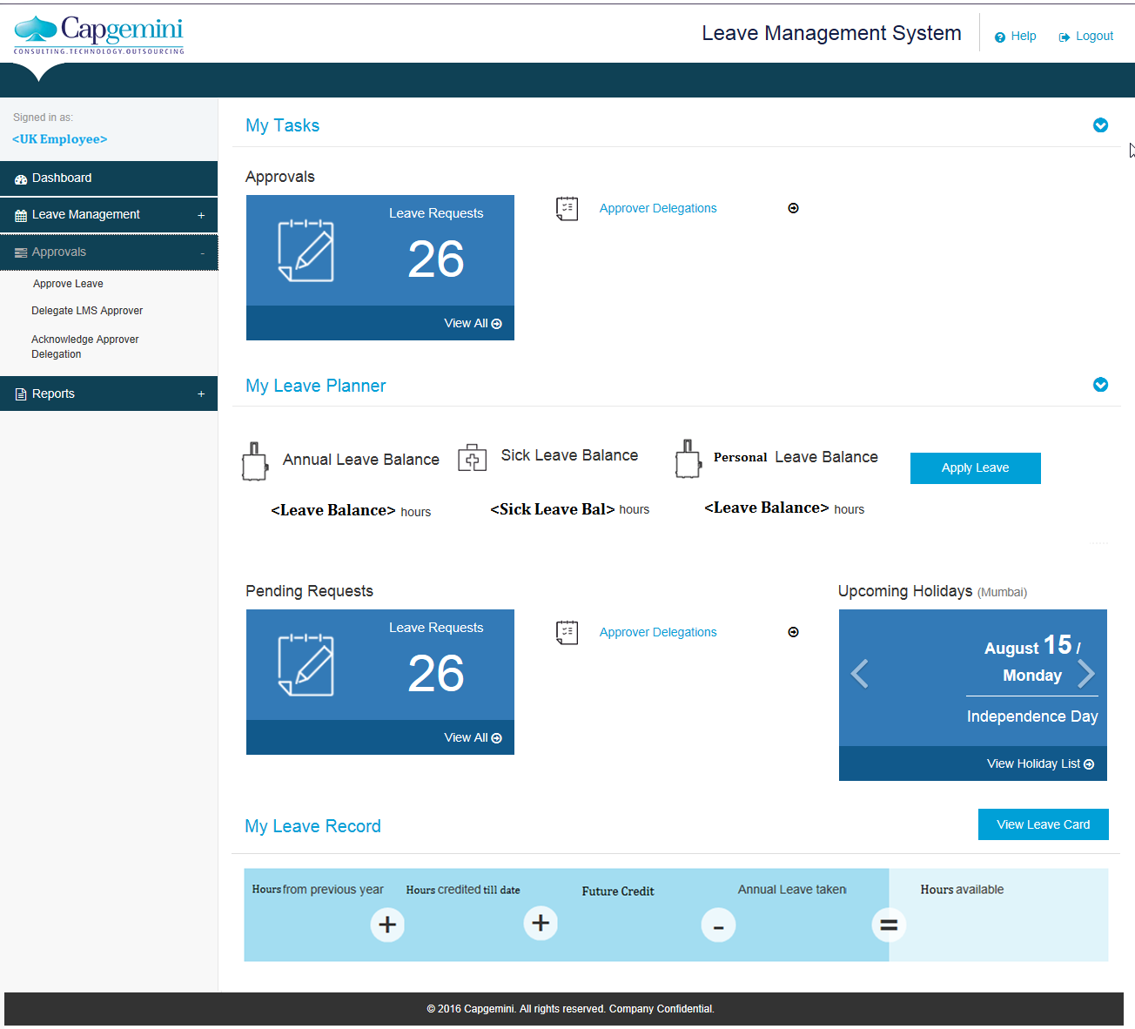

### Home Page🡪Supervisor



### Leave accrual

* Vacation Leave accrual to happen bi-monthly basis as per chart provided in employee handbook for FS employee and iGATE employees





* For the IGATE employees that come to FS – many will have a balance of between 1 & 15 days that they will be able to use through the end of 2018.

Query to Liz with response🡪

* Will we have to do upload for IGATE employees at the start of the year? **Yes, this should be provided to you by the IGATE team sometime in the final week of December, 2016.**
* Is it carryover from IGATE system? **Yes, it will be anywhere from 1-15 days of vacation balance and those hours will need to be included in the “Rollover from previous year” bucket in LMS.**
* Along with the system carry over in 2017 the balance is this leave should also be carryover to 2018 as per the statement? **Yes, the employee’s vacation balance will first deduct from the 2016 rolled over hours and until all of those hours are used up, the employees’ vacation hours must be deducted from that rolled over balance first. If they fail to take current accrued vacation hours (i.e. 2017) then they will forfeit those hours just like everyone else if they fail to take at least 50% of their 2017 accrual by 12/31/17 and so on.**
* If they schedule vacation – this bank of hours brought from IGATE should be used first instead of the new plan accrual.
* Vacation accrual: For California residents only.
  + System will stop vacation accrual when balance becomes 1.5 times of vacation eligibility.
  + If and when the vacation balance goes below 1.5 times of eligibility, then accrual will start again, starting with the cycle in which balance went below 1.5 times of eligibility.
  + System will ensure that vacation balance will not exceed 1.5 times of eligibility.
  + Changes will be made in the current leave credit job to handle this requirement.
* Personal leave accrual to happen bi-monthly basis as per chart provided in employee handbook

|  |  |
| --- | --- |
| **Personal Day Accrual** | |
| **Number of Days** | **Accrual Rate** |
| 2 days per year | 1.33 hours per month / 16 hours per year |

* Vacation leave and Personal days require leave accrual on semi-monthly basis.
* Sick leave accrual of 40 hours should be done at the start of the year
* **Response from Liz : The IGATE employees will also be afforded the same sick leave benefit, so please note that all FS SBU employees as of 1/1/17 need to have 40 hours of sick leave loaded in their balance as of 1/1/17.**
* Hourly basis employees do not receive any leave benefits.
  + System will apply vacation accrual for employees whose status has changed from hourly to salaried from the salaried effective date.
  + System will identify employees working on hourly basis and will not credit leaves for these employees.
  + LMS will not allow Hourly and Daily salaried basis employees to plan/apply for leave in LMS and they do not submit timecard against leave project codes in Clarity.
* Promotions:
  + System will add vacation hours retro-effectively from the effective date of promotion.
  + This change will not apply to rollover as rollover is applicable on 31st Dec, and promotion is effective 1st Jan.
  + If employee is promoted effective 1st Dec, then system will apply the rollover benefit.
  + If employee is promoted effective 1st Jan, and is notified in May, then system will also apply the forfeit/lapse policy.
  + If it is a backdated promotion, the rollover, forfeit/lapse will be adjusted based on new designation.
  + The employee pull job from FSDB will be modified to ensure that leave credit and other entities are changed effective from promotion date.

### Leave Credit job for US

* Scheduled batch for leave credit should run every day.
* However, the steps will be executed only on those dates which are uploaded by ADP team
* If it is being executed on or before 15th, then first it will identify all those leave types whose credit is semi-monthly
* If it is being executed on the last day of the month, then it needs to consider all the leave types whose credit is semi-monthly and monthly.
* Following are the steps for leave credit for US which will execute only on dates specified by ADP:
  + Take list of all the employees who are on Annual Salary Pay in US. [Pay basis 🡪annual salary pay]
  + Calculate no. of working days in the current pay cycle based on the joining date and the end date of the current cycle. The start and end date of the current pay cycle would be 1st and 15th of the month respectively if the date of job execution is before 15th and would be 16th and last date of the month respectively if the date of job execution is after 15th.
  + Take a list of all employees who are on Sabbatical leave, Family Medical Leave of Absence, Unpaid Personal Leave of Absence, and Military Leave in the current pay cycle. Consider this list as list of employees on Unpaid Leave.
  + Get the leave eligibility for all employees based on the eligibility criteria or exception offer details.
  + The number of working days in current pay cycle is equal to the number of week days in the current pay cycle.
  + If the employee joining date is in the same month then following is the formula: No. Of working days = Number of weekdays in the current pay cycle falling after the date of joining
  + Find out the actual number of days to be credited as per follows:
  + If the month is December, then no. of leaves to be credited is Max Leaves – (Credit eligibility \* (12 or 24 based on whether the leave type being considered is semi-monthly type or monthly type)) + credit eligibility
  + For other months, the no. of leaves to be credited is Credit Eligibility
  + Credit the number of days to all those employees who are part of the list obtained in point 1 but are not on Unpaid leave, based on the following criteria
    - If the joining date of the employee is not in the current pay cycle, then credit the number of leave as per eligibility.
    - If the joining date of the employee is in the current pay cycle, then credit the number of leave as per formula: (Days worked in month \* 8)/ 86.67 \* Credit Eligibility of the employee
  + For all employees whose name appear in the Unpaid leave list, credit 0 leave with the exception reason as “No leave credited due to unpaid leave taken”.
  + For all employees whose home address is California as per iConnect, verify if the leave balance is more than 1.5 times the eligibility. If yes, deduct the excess leave with the exception reason as “Leave lapsed as balance is more than 1.5 times the eligibility”.
  + If the month is December and the pay cycle is the second pay cycle, then identify the balance of current year. Carry forward the same to the next year if it is positive.
  + If the number of leaves carried forwarded is more than the Max CF allowed, then make an additional debit entry equal to ( Leave balance carry forwarded – Max CF). Also mention the reason as “Leave lapsed as per policy”. Exceptions to this step are employees whose home address is California (as per iConnect) and / or who have opted for Rollover extension feature.
  + If the month is April and the date is the last date of the month, identify the number of leave carried over from last year for each employee and verify whether the respective employee has availed those leave or not. If not then the excess leave should be debited with the exception reason as “Leave forfeited for last year”. Exceptions to this step are employees whose home address is California (as per iConnect) and / or who have opted for Forfeiture Extension.
  + On all dates, job will check whether there is any employee whose rollover/ forfeiture extension ends on the current date. If yes, rollover/forfeiture logic will be implemented for that employee.

### Carryover & Forfeiture

Vacation Leave

* for all individuals except Vice-Presidents, Directors and Principals, up to one half of an individual's annual accrual amount will automatically roll over into the next calendar year
* Unused vacation that exceeds one half of the individual's annual accrual amount will be forfeited
* Individuals have until April 30th of the year immediately following the year in which they accrued the unused vacation to use their vacation carryover balance.
* Any prior year's balance that remains on April 30 will be forfeited
* The chart below illustrates the maximum roll over amount based upon an employee's annual accrual:

|  |  |
| --- | --- |
| **Days Earned per year** | **Maximum Roll Over** |
| 15 | 8 |
| 20 | 10 |
| 22 | 11 |

* Vice-Presidents and Principals will be able to roll over up to five days of accrued, unused vacation time
* Unused vacation time that exceeds five days will be forfeited
* Vice-Presidents and Principals have until April 30 of the year immediately following the year in which they accrued the unused vacation to use their vacation carryover balance
* Any prior year's balance that remains on April 30 will need to be forfeited
* California employees: Vacation balance rollover and forfeit/lapse amount will not be applied for employees who are California residents.
  + During rollover for employees who are California residents, the rollover will not exceed 1.5 times of eligibility, i.e., maximum vacation that is rolled over will not exceed 1.5 times of eligibility.
  + Employees who are residing in California - Only home address will be considered since this rule applies only to the employees living in California, and does not apply to employees who travel to California for work and are not residents.
  + This policy is applicable to VPs, Directors and Principals also.
* Carryover of Senior Manager will be limited to 40 hours carry forward – which would match the other grade E (principal)
  + Response from Liz: **This is correct however tis designation is able to rollover their current allowed amount from 2016 into 2017 and then beginning in 2017, they will be at the same roll over amount as Principals.**

Personal Days Leave

* Personal leave may not be carried over and accumulated from year to year
* Personal days not used during a calendar year are forfeited.

Sick Leave

* Sick Leave would not be carried over and would be forfeited at the end of the year.

### Dashboard

1. My Tasks 🡪 Collapsible control
   1. Approvals
   2. Leave Requests 🡪 Label displaying the count of Pending Leave requests for approval
   3. View All 🡪 Link to redirect to the form where all pending request for approval would be available.
   4. Approver Delegations 🡪 Link to redirect to the form to Acknowledge Approver Delegation.
2. My Leave Planner 🡪Collapsible control
   1. Vacation Leave Balance 🡪 Label displaying the Leave balance in hours of the logged in employee.
   2. Sick Leave Balance 🡪 Label displaying the Sick Leave balance in hours of the logged in employee.
   3. Personal Days Balance 🡪 label displaying the personal days balance in hours.
   4. Apply Leave 🡪 Button to redirect to the form to apply leave.
   5. Pending Requests 🡪 Label displaying the count of pending leave requests of the logged in employee which is not approved yet.
   6. View All 🡪 Link to redirect to the form where all employee request would be available for view / cancellation.
   7. Approver Delegations 🡪 Link to redirect to the form of Delegate LMS approver.
   8. Upcoming Holidays (Employees tagged location)🡪 scrolling control, this label would display the holidays of the year, the default displayed would the upcoming holiday date and event.
   9. View Holiday List 🡪 link to redirect to the form having the view of the tagged location holiday list.
   10. View Leave Card 🡪 Button control, on click of which the form would be redirected to the logged in employees leave card.
3. My Leave Record
   1. Hours from previous year 🡪 label control displaying the count of hours carry forwarded from previous year of the logged in employee.
   2. Hours credited till date 🡪 label control displaying the count of hours credited till date of the logged in employee.
   3. Future credit 🡪 label control displaying the Projected leave to be credited for the logged in employee.
   4. Annual leave taken🡪 label control displaying the count of leaves taken till date.
   5. Hours available 🡪 label control displaying the current balance in hours of the logged in employee.

### Leave Management >> Apply Leave

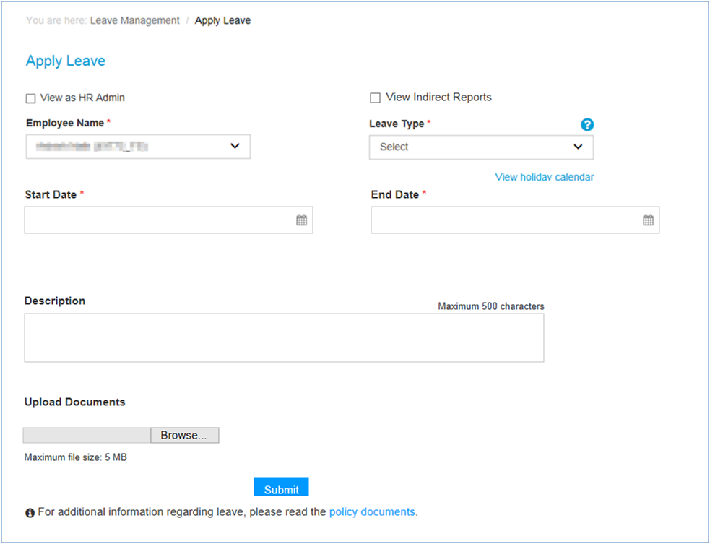

1. Apply leave feature would enable employee to apply leave in LMS application
2. Following features to be available on screen
   1. View as HR Admin 🡪 Check box control
      1. This would be visible or available only if the logged in employee is having an role as ‘US HR Admin’
      2. When the control is checked the Employee Name field would be an auto extender control, which would allow searching all active FS US location employees.
      3. Through this feature US Admin would be able to apply leave on behalf of an employee.
   2. View Indirect Reports 🡪 Check box control
      1. This would be visible or available only if the logged in employee is having indirect reportees
      2. When the control is checked the Employee Name dropdown would have names of the logged in employees indirect reports (reportees of reportee).
      3. Through this feature Employee supervisor’s supervisor would be able to apply leave on behalf of an employee.
   3. Employee Name 🡪 Mandatory dropdown control
      1. The dropdown would have by default the Employee Name (ID) selected.
      2. The list would be the logged in employees direct reportees.
      3. When the Indirect reports check box is checked the employee name dropdown would have names of the logged in employees indirect reportees (reportees of reportee)
      4. When the View as HR Admin is checked the Employee Name field would be an autol extender, which would allow searching all active FS US location employees.
   4. Leave Type 🡪 Mandatory dropdown control
      1. This would have the list of all applicable Leave types for US region.
      2. Leave types
         1. [Bereavement Leave](#Bereavement)
         2. [Disability Leave](#disability)
         3. [Family Medical Leave of Absence](#FMLA)
         4. [Jury Leave](#Jury)
         5. [Military Leave](#Military)
         6. [Personal Leave](#Personal)
         7. [Sabbatical Leave](#Sabbatical)
         8. [Sick Leave](#sick)
         9. [Unpaid Personal Leave of Absence](#unpaid)
         10. [Vacation Leave](#unpaid)
   5. Start Date 🡪 Mandatory Date control
   6. End Date 🡪 Mandatory Date control
   7. Description 🡪 Free flow text control
      1. The control should accept only 500 characters
      2. Note to be mentioned as ‘(max 500 chars. only)’
   8. Start Date Hours 🡪 Textbox control, 0-9 whole number to be accepted
   9. End Date Hours 🡪 Textbox control, 0-9 whole number to be accepted
   10. Upload document 🡪 browse and upload control
       1. The control would be mandatory only for leave types Sabbatical, Family Medical Leave of Absence, Personal Leave of Absence, Bereavement, Jury Duty, Military Leave, Short/Long term Disability and Sick leaves
       2. File size allowed should be less than or equal to 5 mb.
       3. Note for file size to appear as ‘**Max file size should be less than or equal to 5 MB**’
       4. Note to be displayed near the field the type of upload document required.
          1. Bereavement Leave 🡪 ‘Copy Of Obituary’
          2. Disability Leave

🡪 Link to ‘Short Term Disability Form’ <Form available at documents section>

🡪Link to ‘Long Term Disability Form’

* + - 1. Family Medical Leave of Absence

🡪 Link to Medical Certification Form   
🡪 link to Employee Request Form

* + - 1. Jury Leave 🡪 ‘Copy of Stub Receipt.’
      2. Military Leave 🡪 ‘Copy of Orders.’
      3. Sick Leave 🡪 ‘3 Days or More (Up To 5 Days) Doctor's Note Needed.’
      4. Unpaid Personal Leave of Absence 🡪 link to ‘Personal Leave Form’
  1. Submit 🡪 Button control
     1. On Click of submit button, leave should be applied successfully.
     2. Validations to be applied on submit button
        1. If Leave Type is not selected, then message to appear as ‘Please select Leave Type.’
        2. If Start Date is not entered, then message to appear as ‘Please enter Start Date’.
        3. If End Date is not entered, then message to appear as ‘Please enter End Date’.
        4. If document is not uploaded where it is mandatory then message to appear as ‘Please upload relevant document’
        5. If the Start Date or End date is on weekend or holiday then message to appear as ‘You cannot apply for leave on your weekly-off days or holidays.’
        6. Employee can apply backdated leave for past 2 months from current month. If leave is applied beyond that the message to appear as ‘Date Should Be Within Two Month From Today's Date’
        7. If two leave types have over lapping dates entered then message to appear as ‘You have already applied leave for one or more dates selected. Hence, you cannot apply for leave on the same date again’
        8. For Bereavement/Jury duty/Military leave/Short/Long term disability leaves, Once the request is submitted by employee, an email alert will be triggered to people process team for their decision (approve/reject). Reminders will be sent to people process 15 days prior to leave start date
        9. For Personal leave of absence/Family medical leave of absence/Sabbatical/Illness/Sick leave (for 3 or more days [only for Sick leave]), this request in LMS will trigger an email alert to employee’s supervisor for its approval (approve/reject). Reminders will be sent to supervisor 15 days prior to leave start date
        10. Once the request is approved by supervisor, an email alert will be triggered to people process team for their decision. Reminders will be sent to people process every day prior to leave start date
     3. The leave information should be sent to clarity for employee to fill in Timesheet.
     4. If Employee is applying for leave then mail to be sent to Supervisor/US HR Admin (basis Leave type).
     5. If Supervisor/ US HR Admin / Indirect Supervisor has applied for leave on behalf of Employee then mail to be sent to Supervisor/US HR Admin (basis Leave type) and the requestor of the leave request should be kept in CC of the email.
  2. Icon  next to Leave Type opens popup which would provide details of the selected leave type
  3. View holiday calendar 🡪 link to redirect to the available holiday calendar of US region.

1. If Holiday calendar is not available for a particular year then leave application should not be allowed in LMS.

Apply Bereavement Leave

* Following fields to be available on the form for submitting Bereavement leave
  + Start Date 🡪 Mandatory date time control
  + End Date 🡪 Mandatory date time control
  + Description 🡪 multiline non mandatory text box control, allowing up to 500 char
  + Upload Document🡪 upload functionality
* Up to three (3) working days of leave with pay (not charged to other leave time) shall be granted to regular
* If leave applied in excess then message to appear as ‘You cannot apply leave for the selected number of days as it exceeds the eligibility for the selected leave type. Please [refer to KM for Policy Document](http://km20.capgemini.com/book/585257).’
* If start date is greater than end date then message to appear as ‘End Date Should Be Greater Than or same as Start Date.’
* Leave applied for backdated date more than 2 months then message to appear as ‘Date Should Be Within Two Month From Today's Date’
* Post leave application the request would goto to US HR Admin for approval.
* Post approval from US HR Admin, the leave request should be approved and employee should be able to apply successfully timesheet is clarity.
* Mail to be sent post successful leave application

|  |  |  |  |  |  |  |  |  |
| --- | --- | --- | --- | --- | --- | --- | --- | --- |
| From: <Employee>  To: <US HR Admin(s)>  CC:<Employee>,<Employee Supervisor>  Subject: <Leave Type> submitted by <Employee Name>  Body:  Hi,   This is to inform you that <Employee Name (ID)> has submitted following leave request.   |  |  |  |  | | --- | --- | --- | --- | | **Leave Type** | **Start Date** | **End Date** | **Effective Leave** | |  |  |  | 3 day(s) |   Remarks:  Note:   * Please login to [<LMS](https://lms.fs.capgemini.com) url> to access LMS application * For any technical/functional issues, kindly raise your service request using : [FS SBU Service desk portal](http://arserver.eu.capgemini.com:8080/arsys/forms/eu-itsm-prod.corp.capgemini.com/SRS:ServiceRequestConsole/?mode=submit&F303900000=4&F303900900=SRGAA5V0GKHD1AMQ7J0M1DP80F9286&F303906700=0&F303902000=0&F303902100=0) (<service desk link>).   Regards, <EmployeeName(ID)> |

Apply Disability Leave

* Following fields to be available on the form for submitting Disability Leave
  + Start Date 🡪 Mandatory date time control
  + End Date 🡪 Mandatory date time control
  + Description 🡪 multiline non mandatory text box control, allowing up to 500 char
  + Start Date Hours 🡪 non mandatory text box control, allowing whole number ranging 0-9
  + End Date Hours 🡪 non mandatory text box control, allowing whole number ranging 0-9
  + Upload Document 🡪 mandatory upload document functionality
    - Form templates to be provided
    - Short term disability form :
    - Long term disability form: 
* Disability is defined as five (5) or more consecutive workdays away from work due to illness or injury (physician certification must be provided)
* An Employee must be employed at Capgemini FS GBU for at least six (6) months to be eligible for disability pay. This is based on the global hire date.
* First, any unused sick days are paid out at 100% starting from the day the Employee is deemed disabled
* For the first and second weeks of disability after sick days are used, the Employee is paid 100% of their base salary, provided they are deemed disabled according to Capgemini FS GBU’s disability advisor.
* For the third and fourth weeks of disability, the Employee receives 80% of their base salary, provided they are deemed disabled according to Capgemini FS GBU’s disability advisor.
* For the fifth week of disability through the remaining coverage period (180 calendar days maximum), the Employee receives 60% of their base salary, provided they are still disabled as determined by Capgemini FS GBU’s disability advisors.
* Employees may use accrued vacation or personal time to supplement the unpaid periods of their disability leave of absence.
* When an employee applies disability leave, the leave should be divided as per the policy stated above and the bifurcation should be displayed in Approve Leave for disability an Update Disability leave form.
* Once the request is submitted by employee, an email alert will be triggered to people process team for their decision (approve/reject). Reminders will be sent to people process 15 days prior to leave start date.
* Mail to be sent post leave application

|  |  |  |  |  |  |  |  |  |
| --- | --- | --- | --- | --- | --- | --- | --- | --- |
| From: Employee  To:US HR Admin(s)  CC: Employee, Supervisor  Subject: <Leave Type> submitted by <Employee Name>  Body:  Hi,   This is to inform you that <Employee Name (ID)> has submitted following leave request.   |  |  |  |  | | --- | --- | --- | --- | | **Leave Type** | **Start Date** | **End Date** | **Effective Leave** | |  |  |  | <> hours(s) |   Remarks:  Note:   * Please login to [<new](https://lms.fs.capgemini.com) application URL> to access LMS application * For any technical/functional issues, kindly raise your service request using : [FS SBU Service desk portal](http://arserver.eu.capgemini.com:8080/arsys/forms/eu-itsm-prod.corp.capgemini.com/SRS:ServiceRequestConsole/?mode=submit&F303900000=4&F303900900=SRGAA5V0GKHD1AMQ7J0M1DP80F9286&F303906700=0&F303902000=0&F303902100=0) (Employee Management >> Leave Management System).   Regards, EmployeeName(ID) |

Apply Family Medical Leave of Absence

* Following fields to be available on the form for submitting Family Medical Leave of Absence
  + Start Date 🡪 Mandatory date time control
  + End Date 🡪 Mandatory date time control
  + Description 🡪 multiline non mandatory text box control, allowing up to 500 char
  + Start Date Hours 🡪 non mandatory text box control, allowing whole number ranging 0-9
  + End Date Hours 🡪 non mandatory text box control, allowing whole number ranging 0-9
  + Upload Document 🡪 mandatory upload document functionality
    - Medical Certification form : 
    - Employee Request Form:
* Employees in the United States are eligible for FMLA leave if they have been employed for at least 12 months
* FMLA can be taken in hours 🡪 as confirmed by Liz.
* This request in LMS will trigger an email alert to employee’s supervisor for its approval (approve/reject). Reminders will be sent to supervisor 15 days prior to leave start date.
* Once the request is approved by supervisor, an email alert will be triggered to people process team for their decision. Reminders will be sent to people process every day prior to leave start date.
* Mail to be sent post leave application to supervisor

|  |  |  |  |  |  |  |  |  |
| --- | --- | --- | --- | --- | --- | --- | --- | --- |
| From: Employee  To: Supervisor  CC: Employee  Subject: <Leave Type> submitted by <Employee Name>  Body:  Hi,   This is to inform you that <Employee Name (ID)> has submitted following leave request.   |  |  |  |  | | --- | --- | --- | --- | | **Leave Type** | **Start Date** | **End Date** | **Effective Leave** | |  |  |  | <> hours(s) |   Remarks:  Note:   * Please login to [<new](https://lms.fs.capgemini.com) application url> to access LMS application * For any technical/functional issues, kindly raise your service request using: [FS SBU Service desk portal](http://arserver.eu.capgemini.com:8080/arsys/forms/eu-itsm-prod.corp.capgemini.com/SRS:ServiceRequestConsole/?mode=submit&F303900000=4&F303900900=SRGAA5V0GKHD1AMQ7J0M1DP80F9286&F303906700=0&F303902000=0&F303902100=0) (Employee Management >> Leave Management System).   Regards, Employee Name(ID) |

Mail to be sent post supervisor approval to HR Admin

|  |  |  |  |  |  |  |  |  |
| --- | --- | --- | --- | --- | --- | --- | --- | --- |
| From: Supervisor  To: US HR Admin  CC: Employee  Subject: <Leave Type> approved by Supervisor <Supervisor Name>  Body:  Hi,   This is to inform you that following leave request submitted by <Employee Name (ID)> has been approved.  This is pending for your approval.   |  |  |  |  | | --- | --- | --- | --- | | **Leave Type** | **Start Date** | **End Date** | **Effective Leave** | |  |  |  | <> hours(s) |   Approver Remarks: <Remarks>  Note:   * Please login to [<new](https://lms.fs.capgemini.com) LMS url> to access LMS application * For any technical/functional issues, kindly raise your service request using: [FS SBU Service desk portal](http://arserver.eu.capgemini.com:8080/arsys/forms/eu-itsm-prod.corp.capgemini.com/SRS:ServiceRequestConsole/?mode=submit&F303900000=4&F303900900=SRGAA5V0GKHD1AMQ7J0M1DP80F9286&F303906700=0&F303902000=0&F303902100=0) (Employee Management >> Leave Management System). * Contact Person: Michelle Odisho   Regards, Employee Name(ID) |

Apply Jury Leave

* Following fields to be available on the form for submitting Jury Leave
  + Start Date 🡪 Mandatory date time control
  + End Date 🡪 Mandatory date time control
  + Description 🡪 multiline non mandatory text box control, allowing up to 500 char
  + Start Date Hours 🡪 non mandatory text box control, allowing whole number ranging 0-9
  + End Date Hours 🡪 non mandatory text box control, allowing whole number ranging 0-9
  + Upload Document 🡪 mandatory upload document functionality, copy for stub receipt is required.
* Employees are eligible for up to two (2) weeks pay
* Once the request is submitted by employee, an email alert will be triggered to people process team for their decision (approve/reject). Reminders will be sent to people process 15 days prior to leave start date.
* Mail to be sent

|  |  |  |  |  |  |  |  |  |
| --- | --- | --- | --- | --- | --- | --- | --- | --- |
| From : Employee  To: US HR Admin(s)  CC: Employee, Supervisor  Subject: <Leave Type> submitted by <Employee Name>  Body:  Hi,   This is to inform you that Employee Name (ID) has submitted following leave request.   |  |  |  |  | | --- | --- | --- | --- | | **Leave Type** | **Start Date** | **End Date** | **Effective Leave** | |  |  |  | <> day(s) |   Remarks:  Note:   * Please login to [<new LMS URL>](https://lms.fs.capgemini.com) to access LMS application * For any technical/functional issues, kindly raise your service request using : [FS SBU Service desk portal](http://arserver.eu.capgemini.com:8080/arsys/forms/eu-itsm-prod.corp.capgemini.com/SRS:ServiceRequestConsole/?mode=submit&F303900000=4&F303900900=SRGAA5V0GKHD1AMQ7J0M1DP80F9286&F303906700=0&F303902000=0&F303902100=0) (Employee Management >> Leave Management System).   Regards, Employee Name (ID) |

Apply Military Leave

* Following fields to be available on the form for submitting Military Leave
  + Start Date 🡪 Mandatory date time control
  + End Date 🡪 Mandatory date time control
  + Description 🡪 multiline non mandatory text box control, allowing up to 500 char
  + Start Date Hours 🡪 non mandatory text box control, allowing whole number ranging 0-9
  + End Date Hours 🡪 non mandatory text box control, allowing whole number ranging 0-9
  + Upload Document 🡪 mandatory upload document functionality, copy for orders are required.
* Once the request is submitted by employee, an email alert will be triggered to people process team for their decision (approve/reject). Reminders will be sent to people process 15 days prior to leave start date.
* Mail to be sent

|  |  |  |  |  |  |  |  |  |
| --- | --- | --- | --- | --- | --- | --- | --- | --- |
| From: Employee  To: US HR Admin(s)  CC: Employee, Supervisor  Subject: <Leave Type> submitted by <Employee Name>  Body:  Hi,   This is to inform you that Employee Name (ID) has submitted following leave request.   |  |  |  |  | | --- | --- | --- | --- | | **Leave Type** | **Start Date** | **End Date** | **Effective Leave** | |  |  |  | <> day(s) |   Remarks:  Note:   * Please login to <new LMS url> to access LMS application * For any technical/functional issues, kindly raise your service request using : [FS SBU Service desk portal](http://arserver.eu.capgemini.com:8080/arsys/forms/eu-itsm-prod.corp.capgemini.com/SRS:ServiceRequestConsole/?mode=submit&F303900000=4&F303900900=SRGAA5V0GKHD1AMQ7J0M1DP80F9286&F303906700=0&F303902000=0&F303902100=0) (Employee Management >> Leave Management System).   Regards, Employee Name(ID) |

Apply Personal Days

* Following fields to be available on the form for submitting Personal days
  + Start Date 🡪 Mandatory date time control
  + End Date 🡪 Mandatory date time control
  + Description 🡪 multiline non mandatory text box control, allowing up to 500 char
  + Start Date Hours 🡪 non mandatory text box control, allowing whole number ranging 0-9
  + End Date Hours 🡪 non mandatory text box control, allowing whole number ranging 0-9
* Personal leave should not be carried over and accumulated from year to year. Personal days not used during a calendar year are forfeited.
* This request in LMS will trigger an email alert to employee’s supervisor for its approval (approve/reject). Reminders will be sent to supervisor 15 days prior to leave start date.
* Once the request is approved by supervisor, an email alert will be triggered to people process team for their decision. Reminders will be sent to people process every day prior to leave start date
* Mail to be sent to supervisor

|  |  |  |  |  |  |  |  |  |
| --- | --- | --- | --- | --- | --- | --- | --- | --- |
| From: Employee  To: Supervisor  CC: employee  Subject: <Leave Type> submitted by <Employee Name>  Body:  Hi,   This is to inform you that Employee Name (ID) has submitted following leave request.   |  |  |  |  | | --- | --- | --- | --- | | **Leave Type** | **Start Date** | **End Date** | **Effective Leave** | |  |  |  | <> hours(s) |   Note:   * Please login to [<new](https://lms.fs.capgemini.com) LMS URL> to access LMS application * For any technical/functional issues, kindly raise your service request using : [FS SBU Service desk portal](http://arserver.eu.capgemini.com:8080/arsys/forms/eu-itsm-prod.corp.capgemini.com/SRS:ServiceRequestConsole/?mode=submit&F303900000=4&F303900900=SRGAA5V0GKHD1AMQ7J0M1DP80F9286&F303906700=0&F303902000=0&F303902100=0) (Employee Management >> Leave Management System).   Regards, Employee Name (ID) |

Mail to be sent post supervisor approval

|  |  |  |  |  |  |  |  |  |
| --- | --- | --- | --- | --- | --- | --- | --- | --- |
| From: Supervisor  To:US HR Admin  CC:Employee  Subject: <Leave Type> approved by Supervisor <Supervisor Name>  Body:  Hi,   This is to inform you that following leave request submitted by Employee Name (ID) has been approved.  This is pending for your approval.   |  |  |  |  | | --- | --- | --- | --- | | **Leave Type** | **Start Date** | **End Date** | **Effective Leave** | |  |  |  | <> hours(s) |   Approver Remarks: <Remarks>  Note:   * Please login to [<new](https://lms.fs.capgemini.com) LMS url> to access LMS application * For any technical/functional issues, kindly raise your service request using : [FS SBU Service desk portal](http://arserver.eu.capgemini.com:8080/arsys/forms/eu-itsm-prod.corp.capgemini.com/SRS:ServiceRequestConsole/?mode=submit&F303900000=4&F303900900=SRGAA5V0GKHD1AMQ7J0M1DP80F9286&F303906700=0&F303902000=0&F303902100=0) (Employee Management >> Leave Management System). * Contact Person: Michelle Odisho   Regards, Employee Name(ID) |

Apply Sabbatical Leave

* Following fields to be available on the form for submitting Sabbatical Leave
  + Start Date 🡪 Mandatory date time control
  + End Date 🡪 Mandatory date time control
  + Description 🡪 multiline non mandatory text box control, allowing up to 500 char
  + Upload Document 🡪 mandatory upload document functionality
* <No mention of it in policy document / employee handbook>
* This request in LMS will trigger an email alert to employee’s supervisor for its approval (approve/reject). Reminders will be sent to supervisor 15 days prior to leave start date.
* Once the request is approved by supervisor, an email alert will be triggered to people process team for their decision. Reminders will be sent to people process every day prior to leave start date
* Mail to be sent

|  |  |  |  |  |  |  |  |  |
| --- | --- | --- | --- | --- | --- | --- | --- | --- |
| From: Employee  To: Supervisor  CC: employee  Subject: <Leave Type> submitted by <Employee Name>  Body:  Hi,   This is to inform you that Employee Name (ID) has submitted following leave request.   |  |  |  |  | | --- | --- | --- | --- | | **New Leave Start Date** | **New Leave End Date** | **Leave Type** | **Effective No. Of leave** | |  |  | Sabbatical Leave | <> day(s) |   Remarks:  Note:   * Please login to [<new](https://lms.fs.capgemini.com) LMS URL> to access LMS application * For any technical/functional issues, kindly raise your service request using : [FS SBU Service desk portal](http://arserver.eu.capgemini.com:8080/arsys/forms/eu-itsm-prod.corp.capgemini.com/SRS:ServiceRequestConsole/?mode=submit&F303900000=4&F303900900=SRGAA5V0GKHD1AMQ7J0M1DP80F9286&F303906700=0&F303902000=0&F303902100=0) (Employee Management >> Leave Management System).   Regards, Employee Name (ID) |

Mail to be sent post supervisor approval

|  |  |  |  |  |  |  |  |  |
| --- | --- | --- | --- | --- | --- | --- | --- | --- |
| From: Supervisor  To: US HR Admin  CC: Employee  Subject: <Leave Type> approved by Supervisor <Supervisor Name>  Body:  Hi,   This is to inform you that following leave request submitted by Employee Name (ID) has been approved.  This is pending for your approval.   |  |  |  |  | | --- | --- | --- | --- | | **Leave Type** | **Start Date** | **End Date** | **Effective Leave** | |  |  |  | <> day(s) |   Approver Remarks: <Remarks>  Note:   * Please login to [<new](https://lms.fs.capgemini.com) LMS url> to access LMS application * For any technical/functional issues, kindly raise your service request using : [FS SBU Service desk portal](http://arserver.eu.capgemini.com:8080/arsys/forms/eu-itsm-prod.corp.capgemini.com/SRS:ServiceRequestConsole/?mode=submit&F303900000=4&F303900900=SRGAA5V0GKHD1AMQ7J0M1DP80F9286&F303906700=0&F303902000=0&F303902100=0) (Employee Management >> Leave Management System). * Contact Person: Michelle Odisho   Regards, Employee Name(ID) |
|  |

Apply Sick Leave

* Following fields to be available on the form for submitting Sick Leave
  + Start Date 🡪 Mandatory date time control
  + End Date 🡪 Mandatory date time control
  + Description 🡪 multiline non mandatory text box control, allowing up to 500 char
  + Start Date Hours 🡪 non mandatory text box control, allowing whole number ranging 0-9
  + End Date Hours 🡪 non mandatory text box control, allowing whole number ranging 0-9
  + Upload Document 🡪 mandatory upload document functionality, 3 Days or More (Up To 5 Days) Doctor's Note Needed.
* For US employees 40 hrs of sick leave credit should be done on the start of each year
* If the 40 hrs of sick leave is not consumed by employee in the year then the leaves should lapse and not allowed to be carried forward to next year.
* Employee should not be allowed to take more than 40 hrs of sick leave in LMS
* For leaves applied for 3 consecutive days and above till 5 days should enforce the employees to upload doctor’s certificate.
* All the sick leave applied through LMS should first goto Supervisor for approval and then to People care team for 2nd level approval.
* This policy would also be applicable to STT & LTT employee who post transfer follow US leave policy
* If employee gets transferred from US to any other country then the remaining number of sick leave should get lapsed, if the same employee returns back to US then 40 hrs of sick leave should be credited on the day of return.
* For STT employees, they would follow US policy so for them 40 hrs of sick leave would be credited in US location, on completion of their term the leave would be lapsed, if the same employee is again deployed on STT then again 40 hrs of sick leave would be credited.
* This request in LMS will trigger an email alert to employee’s supervisor for its approval (approve/reject). Reminders will be sent to supervisor 15 days prior to leave start date.
* Once the request is approved by supervisor, an email alert will be triggered to people process team for their decision. Reminders will be sent to people process every day prior to leave start date
* Mail sent

|  |  |  |  |  |  |  |  |  |
| --- | --- | --- | --- | --- | --- | --- | --- | --- |
| From: Employee  To: Supervisor  CC: employee  Subject: <Leave Type> submitted by <Employee Name>  Body:  Hi,   This is to inform you that Employee Name (ID) has submitted following leave request.   |  |  |  |  | | --- | --- | --- | --- | | **Leave Type** | **Start Date** | **End Date** | **Effective Leave** | |  |  |  | <> hour(s) |   Remarks:  Note:   * Please login to [<new](https://lms.fs.capgemini.com) LMS URL> to access LMS application * For any technical/functional issues, kindly raise your service request using : [FS SBU Service desk portal](http://arserver.eu.capgemini.com:8080/arsys/forms/eu-itsm-prod.corp.capgemini.com/SRS:ServiceRequestConsole/?mode=submit&F303900000=4&F303900900=SRGAA5V0GKHD1AMQ7J0M1DP80F9286&F303906700=0&F303902000=0&F303902100=0) (Employee Management >> Leave Management System).   Regards, Employee Name (ID) |

Mail to be sent post supervisor approval

|  |  |  |  |  |  |  |  |  |
| --- | --- | --- | --- | --- | --- | --- | --- | --- |
| From: Supervisor  To: US HR Admin  CC: Employee  Subject: <Leave Type> approved by Supervisor <Supervisor Name>  Body:  Hi,   This is to inform you that following leave request submitted by Employee Name (ID) has been approved.  This is pending for your approval.   |  |  |  |  | | --- | --- | --- | --- | | **Leave Type** | **Start Date** | **End Date** | **Effective Leave** | |  |  |  | <> hour(s) |   Approver Remarks: <Remarks>  Note:   * Please login to [<new](https://lms.fs.capgemini.com) LMS url> to access LMS application * For any technical/functional issues, kindly raise your service request using : [FS SBU Service desk portal](http://arserver.eu.capgemini.com:8080/arsys/forms/eu-itsm-prod.corp.capgemini.com/SRS:ServiceRequestConsole/?mode=submit&F303900000=4&F303900900=SRGAA5V0GKHD1AMQ7J0M1DP80F9286&F303906700=0&F303902000=0&F303902100=0) (Employee Management >> Leave Management System). * Contact Person: Michelle Odisho   Regards, Employee Name(ID) |

Apply Unpaid Personal Leave of Absence

* Following fields to be available on the form for submitting Unpaid Personal Leave of Absence
  + Start Date 🡪 Mandatory date time control
  + End Date 🡪 Mandatory date time control
  + Description 🡪 multiline non mandatory text box control, allowing up to 500 char
  + Start Date Hours 🡪 non mandatory text box control, allowing whole number ranging 0-9
  + End Date Hours 🡪 non mandatory text box control, allowing whole number ranging 0-9
  + Upload Document 🡪 mandatory upload document functionality
    - Personal Leave form : 
* Employees with 5 -9 years of tenure with the company are eligible to apply for a leave of absence up to 12 weeks.
* Employees with 10 years or more of tenure with the company are eligible to apply for a leave of absence up to 24 weeks.
* No vacation or other paid time off will accrue during an LOA.
* This request in LMS will trigger an email alert to employee’s supervisor for its approval (approve/reject). Reminders will be sent to supervisor 15 days prior to leave start date.
* Once the request is approved by supervisor, an email alert will be triggered to people process team for their decision. Reminders will be sent to people process every day prior to leave start date
* Mail sent

|  |  |  |  |  |  |  |  |  |
| --- | --- | --- | --- | --- | --- | --- | --- | --- |
| From: Employee  To: Supervisor  CC: employee  Subject: <Leave Type> submitted by <Employee Name>  Body:  Hi,   This is to inform you that Employee Name (ID) has submitted following leave request.   |  |  |  |  | | --- | --- | --- | --- | | **Leave Type** | **Start Date** | **End Date** | **Effective Leave** | |  |  |  | <> hour(s) |   Note:   * Please login to [<new](https://lms.fs.capgemini.com) LMS URL> to access LMS application * For any technical/functional issues, kindly raise your service request using : [FS SBU Service desk portal](http://arserver.eu.capgemini.com:8080/arsys/forms/eu-itsm-prod.corp.capgemini.com/SRS:ServiceRequestConsole/?mode=submit&F303900000=4&F303900900=SRGAA5V0GKHD1AMQ7J0M1DP80F9286&F303906700=0&F303902000=0&F303902100=0) (Employee Management >> Leave Management System).   Regards, Employee Name (ID) |

Mail to be sent post supervisor approval

|  |  |  |  |  |  |  |  |  |
| --- | --- | --- | --- | --- | --- | --- | --- | --- |
| From: Supervisor  To: US HR Admin  CC: Employee  Subject: <Leave Type> approved by Supervisor <Supervisor Name>  Body:  Hi,   This is to inform you that following leave request submitted by Employee Name (ID) has been approved.  This is pending for your approval.   |  |  |  |  | | --- | --- | --- | --- | | **Leave Type** | **Start Date** | **End Date** | **Effective Leave** | |  |  |  | <> hour(s) |   Approver Remarks: <Remarks>  Note:   * Please login to [<new](https://lms.fs.capgemini.com) LMS url> to access LMS application * For any technical/functional issues, kindly raise your service request using : [FS SBU Service desk portal](http://arserver.eu.capgemini.com:8080/arsys/forms/eu-itsm-prod.corp.capgemini.com/SRS:ServiceRequestConsole/?mode=submit&F303900000=4&F303900900=SRGAA5V0GKHD1AMQ7J0M1DP80F9286&F303906700=0&F303902000=0&F303902100=0) (Employee Management >> Leave Management System). * Contact Person: Michelle Odisho   Regards, Employee Name(ID) |

Apply Vacation Leave

* Following fields to be available on the form for submitting Vacation Leave of Absence
  + Start Date 🡪 Mandatory date time control
  + End Date 🡪 Mandatory date time control
  + Description 🡪 multiline non mandatory text box control, allowing up to 500 char
  + Start Date Hours 🡪 non mandatory text box control, allowing whole number ranging 0-9
  + End Date Hours 🡪 non mandatory text box control, allowing whole number ranging 0-9

|  |  |  |  |  |  |  |  |  |
| --- | --- | --- | --- | --- | --- | --- | --- | --- |
| <Leave Type> submitted by <Employee Name>  request   |  |  |  |  | | --- | --- | --- | --- | | **Leave Type** | **Start Date** | **End Date** | **Effective Leave** | |  |  |  |  |   Remarks: |

### Leave Management >> View/Cancel Leave

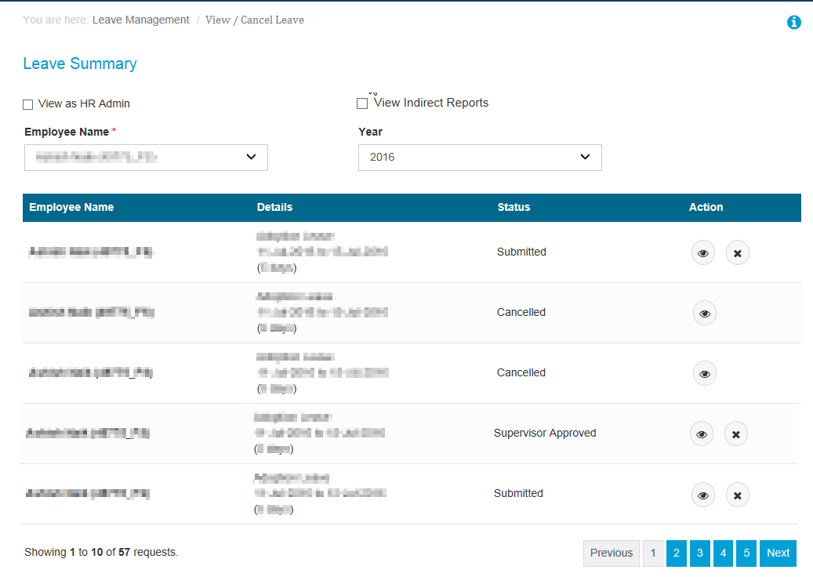

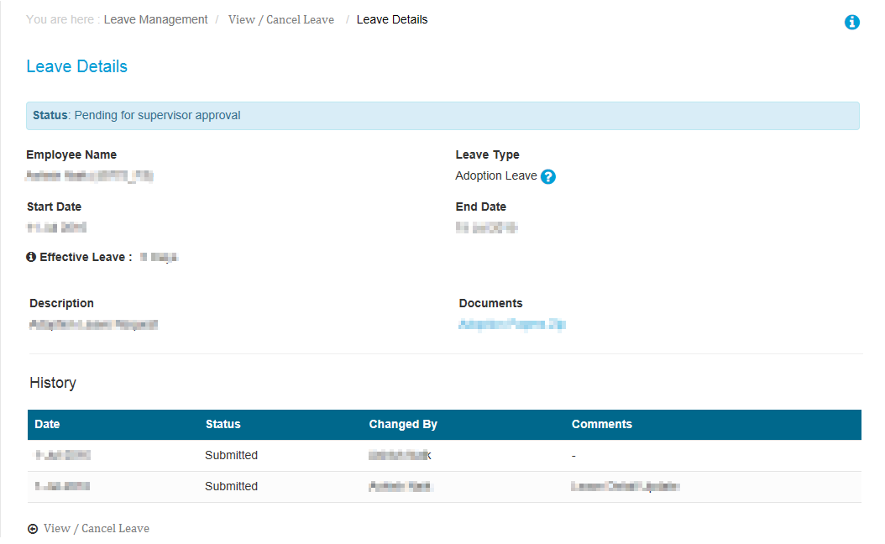

1. The View / Cancel Leave form would enable employee / supervisor / HR to view employee leave summary to cancel a particular leave request.
2. Following details would be available on the screen
   1. View as HR Admin 🡪 Check box control
      1. This would be visible or available only if the logged in employee is having an role as ‘US HR Admin’
      2. When the control is checked the Employee Name field would be an auto extender control, which would allow searching all active FS US location employees.
      3. Through this feature US Admin would be able to apply leave on behalf of an employee.
   2. View Indirect Reports 🡪 Check box control
      1. This would be visible or available only if the logged in employee is having indirect reportees
      2. When the control is checked the Employee Name dropdown would have names of the logged in employees indirect reports (reportees of reportee).
      3. Through this feature Employee supervisor’s supervisor would be able to view/cancel leave on behalf of an employee.
   3. Employee Name 🡪 Mandatory dropdown control
      1. The dropdown would have by default the Employee Name (ID) selected.
      2. The list would be the logged in employees direct reportees.
      3. When the View as HR Admin is checked the Employee Name field would be an auto extender, which would allow searching all active FS US location employees.
   4. Year 🡪 dropdown control
      1. The list would contain the years [current year], [current year -1], [current year-2]
   5. Leave details table 🡪 details would be available of the searched/selected employee
      1. Employee Name (ID)
      2. Details 🡪 details contain the Leave type, the leave dates (Start Date to End Date) , effective Hours in brackets. Eg Adoption Leave 1-09-2016 to 5-9-2016 (40 hrs)
      3. Status 🡪 Status of the leave request (Submitted / Cancelled / etc.)
      4. Action
         1.  🡪 View Details of the leave, popup to open displaying the details of the leave.
         2.  🡪 Cancel the leave request.
3. The Leave Details form would have all the fields entered by employee whilst filling the Apply Leave form, as per the leave type.
4. Employee, Supervisor, Indirect Supervisor or US HR Admin, can view or cancel leave for an employee.
5. When Supervisor / Indirect Supervisor / US HR Admin is cancelling leave on behalf of employee, then the request of the leave cancellation request should be marked in the CC of the email.
6. When the employees leave is cancelled, the leave balance of the employee should be restored and he/she should be able to apply for leave on the same date again.
7. Mail to be sent post cancellation

|  |  |  |  |  |  |  |  |  |  |  |  |  |  |  |  |  |  |  |  |  |  |  |
| --- | --- | --- | --- | --- | --- | --- | --- | --- | --- | --- | --- | --- | --- | --- | --- | --- | --- | --- | --- | --- | --- | --- |
| From: Requestor  To: Employee  CC: Supervisor, US HR Admin (in case the leave type requires HR approval), requestor  Subject: <Leave Type> cancelled by <Requestor Name(ID)>  Body:   |  | | --- | | Hi, | |  | | This is to inform you that <Employee Name (ID)> has cancelled following leave request. | |  | | |  |  |  |  | | --- | --- | --- | --- | | **Leave type** | **Start Date** | **End Date** | **Effective Leave** | |  |  |  |  | | |  | | Remarks: | | Note: | |  | | * • Please login to <https://myleavesit.in.capgemini.com/> to access LMS application * • For any technical/functional issues, kindly raise your service request using: <http://help.capgemini.com/> (Employee Management >> Leave Management System). | |  | |  | | Regards, | | Requestor Name(ID) | |

|  |  |  |  |  |  |  |  |  |
| --- | --- | --- | --- | --- | --- | --- | --- | --- |
| |  |  |  |  | | --- | --- | --- | --- | |  |  |  |  | |  |  |  |  | |

### Approvals >> Approve Leave

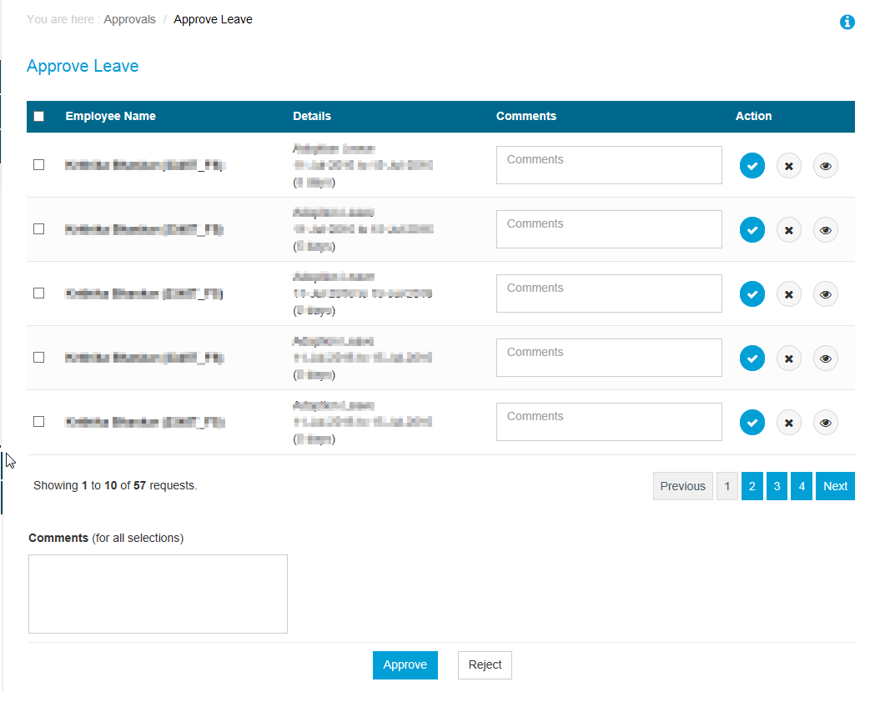

1. The Approve Leave form would be visible only to Supervisors and US HR Admin.
2. Once an employee applies for leave, the leave request goes to supervisor or US HR Admin queue (depending on the leave type) for approval.
3. Such records would be available for approval in Approve leave form.
4. Post supervisor approval, leave requests should be available in US HR Admins queue for approval <depends on the leave type>
5. The latest applied records should be displayed at top in the leave details table.
6. The table would have following details
   1. Employee Name (ID)
   2. Details 🡪 details contain the Leave type, the leave dates (Start Date to End Date), effective Hours in brackets. Eg Adoption Leave 1-09-2016 to 5-9-2016 (40 hrs)
   3. Comments 🡪 free flow text box control, it should allow max 500 chars.
   4. Action

🡪 Approve the leave record

🡪 Reject the leave record

🡪 View details of the leave

* 1. Mail to be sent post approval of record

|  |  |  |  |  |  |  |  |  |
| --- | --- | --- | --- | --- | --- | --- | --- | --- |
| From: Approver Name  To: Employee  CC: Supervisor  Subject: <Leave Type> approved by US HR Admin <HR Admin name>  Body:  Hi,   This is to inform you that your leave request for the following period has been approved.   |  |  |  |  | | --- | --- | --- | --- | | **Leave Type** | **Start Date** | **End Date** | **Effective Leave** | |  |  |  |  |   Approver Remarks:   Note:   * Please login to [<new LMS URL>](https://lms.fs.capgemini.com) to access LMS application * For any technical/functional issues, kindly raise your service request using : [FS SBU Service desk portal](http://arserver.eu.capgemini.com:8080/arsys/forms/eu-itsm-prod.corp.capgemini.com/SRS:ServiceRequestConsole/?mode=submit&F303900000=4&F303900900=SRGAA5V0GKHD1AMQ7J0M1DP80F9286&F303906700=0&F303902000=0&F303902100=0) (Employee Management >> Leave Management System). * Contact Person: Michelle Odisho   Regards, Approver Name(ID) |

* 1. Mail to be sent post rejection of record

|  |  |  |  |  |  |  |  |  |
| --- | --- | --- | --- | --- | --- | --- | --- | --- |
| From: Approver  To: Employee  CC: Supervisor  Subject: <Leave Type> not approved by US HR Admin <HR Admin name>  Body:  Hi,   This is to inform you that your leave plan for the following period has been rejected.   |  |  |  |  | | --- | --- | --- | --- | | **Leave Type** | **Start Date** | **End Date** | **Effective Leave** | |  |  |  |  |   Approver Remarks: <Remark>  Note:   * Please login to <https://lms.fs.capgemini.com> to access LMS application * For any technical/functional issues, kindly raise your service request using : [FS SBU Service desk portal](http://arserver.eu.capgemini.com:8080/arsys/forms/eu-itsm-prod.corp.capgemini.com/SRS:ServiceRequestConsole/?mode=submit&F303900000=4&F303900900=SRGAA5V0GKHD1AMQ7J0M1DP80F9286&F303906700=0&F303902000=0&F303902100=0) (Employee Management >> Leave Management System). * Contact Person: Michelle Odisho   Regards, Approver Name(ID) |

1. Comments (for all sections) 🡪default non mandatory free flow multiline text box control
   1. The entered comments should be applicable for all the records selected.
   2. The comments should be saved when Approve or Reject button is clicked.
   3. The saved comments should be visible when viewing the leave record in history of leave details.
   4. **When rejecting a record, Comments is Mandatory.**
2. Approve 🡪 Button control
   1. On click of Approve button, the selected record should be marked as approved.
   2. If the leave type requires second level approval of HR then the request should be available in HR Queue for approval.
   3. Once the request is approved by Supervisor and/or HR Admin, employee should be able to submit timesheet for the leave period in Clarity.
   4. If approve button is clicked and no records selected then message to appear as ‘Please select at least one record to process’
   5. Mail as per above template to be sent post approval
3. Reject 🡪 Button control
   1. On click of Reject button, the selected record should be marked rejected.
   2. Once the request is rejected, then the employee should not be able to submit timesheet for the selected period in Clarity
   3. If reject button is clicked and no records selected then message to appear as ‘Please select at least one record to process’
   4. Mail as per above template to be sent post rejection.
4. Reminders to be sent to supervisor 15 days prior to leave start date.
5. The requests which require supervisor approval, would goto US HR Admin for approval post supervisor approval.
6. Reminders to be sent to people process every day prior to leave start date.
7. Approve disability leave

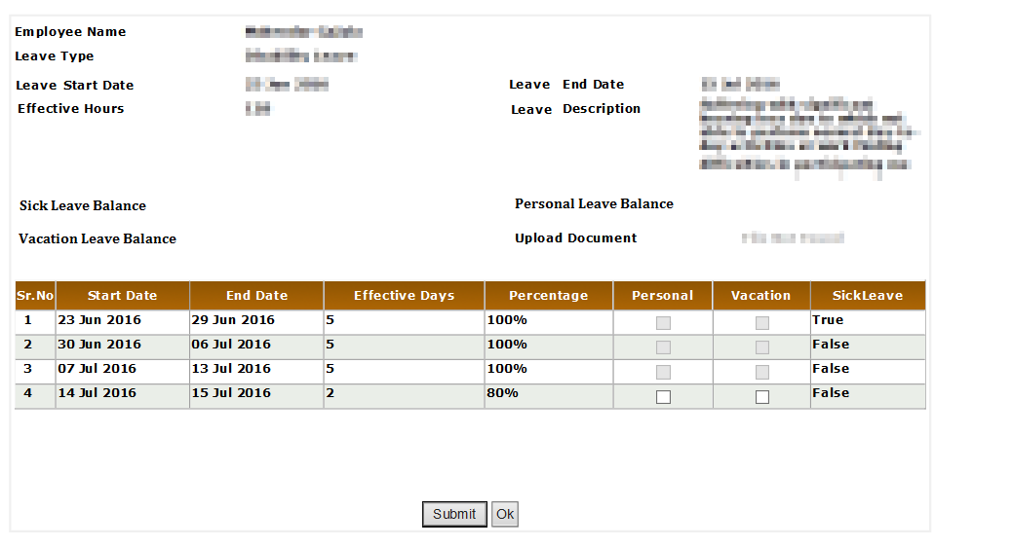

* 1. When Approver clicks on the view details icon to approve his disability leave following details to be displayed on screen
     1. Employee Name
     2. Leave Type
     3. Leave Start Date
     4. Leave End Date
     5. Effective Hours
     6. Leave Description
     7. Sick Leave Balance
     8. Personal Days Balance
     9. Vacation Leave Balance
     10. Uploaded Document
     11. Disability Leave bifurcation as per policy

1. First, any unused sick days are paid out at 100% starting from the day the Employee is deemed disabled.
2. For the first and second weeks of disability after sick days are used, the Employee is paid 100% of their base salary, provided they are deemed disabled according to Capgemini FS GBU’s disability advisor.
3. For the third and fourth weeks of disability, the Employee receives 80% of their base salary, provided they are deemed disabled according to Capgemini FS GBU’s disability advisor.
4. For the fifth week of disability through the remaining coverage period (180 calendar days maximum), the Employee receives 60% of their base salary, provided they are still disabled as determined by Capgemini FS GBU’s disability advisors.
5. Employees may use accrued vacation or personal time to supplement the unpaid periods of their disability leave of absence.
6. Table to contain following fields
   * Sr No
   * Start Date
   * End Date
   * Effective Days
   * Percentage
   * Personal
   * Vacation
   * Sick Leave
7. The disability leave should be divided in 5 days duration starting from the leave start date
8. First 5 days of the leave should be adjusted with the Sick Leave balance if available
   * Percentage should be shown 100% and Sick Leave field should show True
9. Next 5 +5 days (2 records) would be the disability leave
   * Percentage should be shown 100% (as the employee would be paid 100%) and Sick Leave field for both record would be false (as it is already adjusted)
10. Next 5 + 5 days (2 records) would be disability leave
    * Percentage should be shown 80% (as the employee would be paid 80%) and Sick leave field both record should show false
    * The Personal and Vacation record check box should be enabled
    * Approver HR can adjust employees disability record with the available Personal Days and Vacation days
    * They would do so by checking the check box against Personal days and Vacation days
    * Once a duration record is checked for Vacation days and/or Personal days and the form is submitted, then the percentage should be updated to 100%
    * Once a record which was earlier 80% and was marked to be adjusted with Vacation leave then the next 5 + 5 days should be marked as 80%
11. Remaining days until leave end date or until 180 days of disability leave
    * Percentage should be shown 60% and sick leave field for the records would be false
    * If Personal and Vacation record is already checked and adjusted then the check box would not be enabled for following records
    * If Personal and Vacation record is not checked, then for all the remaining records the check box to be enabled to have the Personal and Vacation leaves adjusted with disability leave

### Approvals >> Delegate LMS Approver

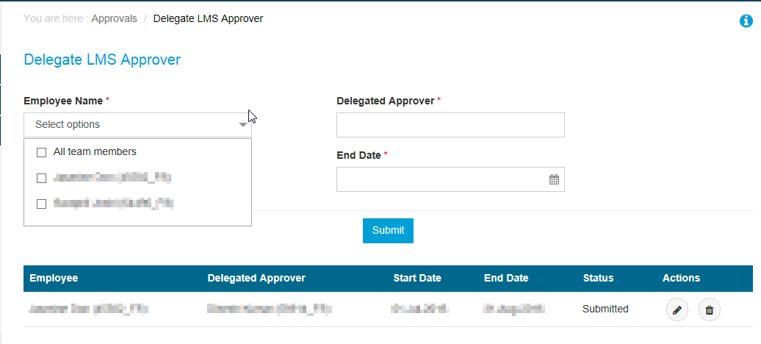

1. The Delegate LMS Approver feature should be visible only when the logged in employee is a supervisor and has direct reportees.
2. Following fields to be available on the screen
   1. Employee Name 🡪 mandatory drop down control
      1. The list would contain the names of logged in employee’s direct reportees.
      2. Check box to be available along with the names.
      3. First in the list to be check box ‘All Team members’ which will give option to select all the team members in the list.
   2. Delegated Approver 🡪 Mandatory auto extender control
      1. The auto extender should allow searching for all active FS employee.
   3. Start Date 🡪 Mandatory date/time control
   4. End Date 🡪 Mandatory date/time control
      1. Check to be implemented as ‘End Date should be greater then start date’
      2. The end date should be future dated
   5. Submit 🡪 Button control
      1. On click of submit button, the request for changing the selected employee(s) approver for the selected duration should be saved successfully.
      2. Validations on submit button
         1. If Employee Name is not selected, then message to appear as ‘Please select atleast one employee’
         2. If Delegate Approver is not selected, then message to appear as ‘Please enter Delegated Approver name’
         3. If Delegate approver name is invalid, then message to appear as ‘Please enter valid Delegated Approver name’
         4. If start date is not entered, then message to appear as ‘Please enter Start Date’
         5. If end date is not entered, then message to appear as ‘Please enter End Date’
      3. The delegation request should be available in the ‘Acknowledge LMS Approver Delegation’ form of Delegated Approver for approval.
   6. Delegation details table 🡪 table control
      1. Employee 🡪 selected Employee Name (ID)
      2. Delegated Approver 🡪 approver Employee Name (ID)
      3. Start Date
      4. End Date
      5. Status
      6. Actions

 🡪Edit the end date of the Delegation request

🡪Popup to open, with editable end date, once updated, the request should be save successfully

🡪 Delete the Delegation request

1. The Delegation Request can be edited even if the approver has approved the request.
2. Post update an updated email should be sent to approver for approval with updated details.
3. Mail to be sent post raising the request

|  |
| --- |
| From: Requestor  To: Delegated approver  CC: employee for whom delegation request was raised, requestor  Subject: Approval rights  Body:  Hi,   This is to Inform you that Requestor name (ID) has delegated leave approval rights of Employee Name (ID) to you. This is pending for your approval.   Note:   * Please login to <new LMS url> to access LMS application * For any technical/functional issues, kindly raise your service request using : [FS SBU Service desk portal](http://arserver.eu.capgemini.com:8080/arsys/forms/eu-itsm-prod.corp.capgemini.com/SRS:ServiceRequestConsole/?mode=submit&F303900000=4&F303900900=SRGAA5V0GKHD1AMQ7J0M1DP80F9286&F303906700=0&F303902000=0&F303902100=0) (Employee Management >> Leave Management System).   Regards, Requestor (ID) |
| Mail to be sent post Delegation request is updated |
| From: Requestor  To: Delegated approver  CC: employee for whom delegation request was raised, Requestor  Subject: Delegation Approval rights updated  Body:  Hi,   This is to Inform you that the delegated leave approval rights by Requestor name (ID) has been updated. This is pending for your approval.   Note:   * Please login to <new LMS url> to access LMS application * For any technical/functional issues, kindly raise your service request using : [FS SBU Service desk portal](http://arserver.eu.capgemini.com:8080/arsys/forms/eu-itsm-prod.corp.capgemini.com/SRS:ServiceRequestConsole/?mode=submit&F303900000=4&F303900900=SRGAA5V0GKHD1AMQ7J0M1DP80F9286&F303906700=0&F303902000=0&F303902100=0) (Employee Management >> Leave Management System).   Regards, Requestor (ID) |

### Approvals >> Acknowledge Approver Delegation

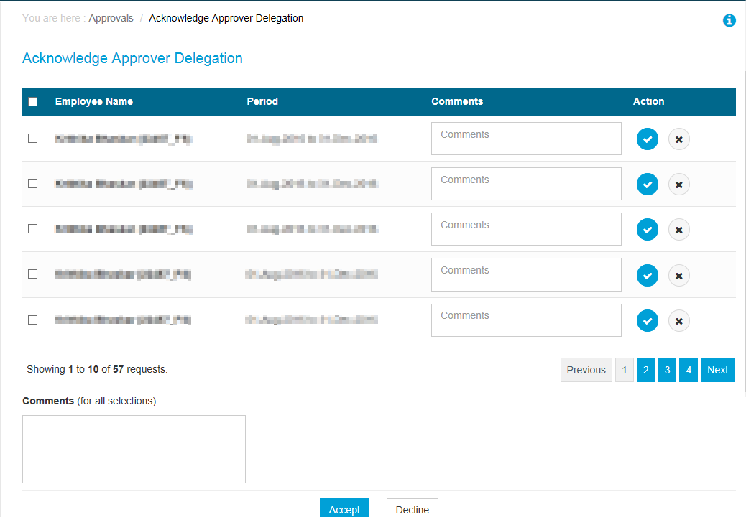

1. The Acknowledge Approver Delegation would enable user to approve the Delegate approver requests
2. Following fields to be available on screen
   1. Delegation details table
      1. Employee Name 🡪 Employee Name (ID) for whom the delegation request was raised
      2. Period 🡪 Start Date to End Date available in Delegation request.
      3. Comments 🡪 free flow multiline text box control
      4. Action

 🡪Accept

 🡪 Reject

* 1. Comments 🡪 free flow multiline text box control
     1. The comments filled in this text would be applicable for all the selected employee records from the table
     2. On click of Accept button, the comments should be saved against the request and should be available in History
  2. Accept 🡪 Button control
     1. On click of Accept button, the selected records from the Delegate approval request(s) should be approved.
     2. The leave requests raised by the selected employee during the mentioned period should be routed to the new said approver for leave approvals.
  3. Decline 🡪 Button control
     1. On click of Decline button, the request should be rejected.
     2. Comments is mandatory for rejection

Mail to be sent post approval

|  |
| --- |
| From: Delegated Approver  To: Employee for whom request was raised  CC: Requestor  Subject: Approval rights accepted  Body:  Hi,   This is to Inform you that approval rights delegated by Requestor name (ID) are accepted by Delegated Approver name (ID)  Effective Dates of delegation:  Start Date: <> End Date: <>   Note:   * Please login to [<new](https://lms.fs.capgemini.com) LMS url> to access LMS application * For any technical/functional issues, kindly raise your service request using : [FS SBU Service desk portal](http://arserver.eu.capgemini.com:8080/arsys/forms/eu-itsm-prod.corp.capgemini.com/SRS:ServiceRequestConsole/?mode=submit&F303900000=4&F303900900=SRGAA5V0GKHD1AMQ7J0M1DP80F9286&F303906700=0&F303902000=0&F303902100=0) (Employee Management >> Leave Management System).   Regards, Approver name (ID) |

Mail to be sent post rejection

|  |
| --- |
| From: Delegated Approver  To: Employee  CC: Requestor  Subject: Approval rights rejected  Body:  Hi,   This is to Inform you that approval rights delegated by Requestor Name (ID) are declined by Delegated Approver name(ID)   Note:   * Please login to [<new](https://lms.fs.capgemini.com) LMS approver> to access LMS application * For any technical/functional issues, kindly raise your service request using : [FS SBU Service desk portal](http://arserver.eu.capgemini.com:8080/arsys/forms/eu-itsm-prod.corp.capgemini.com/SRS:ServiceRequestConsole/?mode=submit&F303900000=4&F303900900=SRGAA5V0GKHD1AMQ7J0M1DP80F9286&F303906700=0&F303902000=0&F303902100=0) (Employee Management >> Leave Management System).   Regards, Delegated approver name (ID) |

### Admin >> Manage Holiday List –[Feature not required as this would be one time set up from backend]

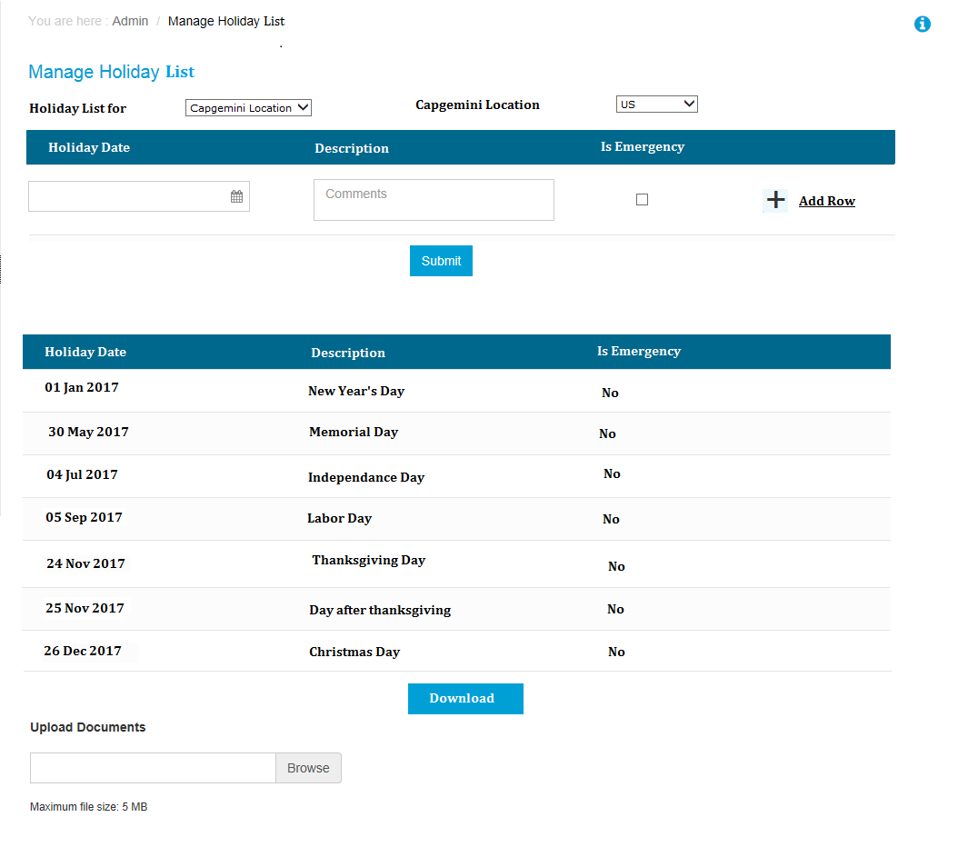

1. ~~This screen would be available to user with US Admin role in LMS application~~
2. ~~This form would enable user to set up the holiday list the selected location.~~
3. ~~Following fields to be available in the form~~
   1. ~~Holiday List for 🡪 dropdown control~~
      1. ~~List to have options as Capgemini Location (default) and Captive Location~~
   2. ~~Capgemini Location 🡪 dropdown control~~
      1. ~~List to have all the HR FS locations set up in LMS~~
      2. ~~If US HR Admin is logged in, then US location should be default selected.~~
   3. ~~Holiday set up 🡪 table control~~
      1. ~~Holiday Date – Date/time control~~
         1. ~~Holiday date cannot be a weekend~~
      2. ~~Description 🡪 Textbox control~~
      3. ~~Is Emergency 🡪 checkbox control~~
      4. ~~+ Add row 🡪 on click of the plus sign, additional row to be added~~
         1. ~~To Add new row, all the above details have to be filled.~~
      5. ~~Delete 🡪 link, after a row is added, option to delete the currently entered row to be provided.~~
   4. ~~Submit 🡪 Button control,~~
      1. ~~On click of the Submit button, the holiday entry should be sent for approval~~
4. ~~Holiday List~~
   1. ~~Table that would display the approved holiday list for the year.~~
5. ~~Download 🡪 the current holiday list can be downloaded in an excel file~~
6. ~~Upload 🡪 the holiday list alternatively can be uploaded and sent for approval~~
   1. ~~The file should be only in .xls or .xlsx format~~
   2. ~~The list to be scanned to see if the similar list is already available, if available then message to appear as ‘Holiday list already available’~~
   3. ~~The new entry should be saved and sent for approval.~~

~~Mail to be sent post holiday list entry~~

|  |
| --- |
| ~~From:~~  ~~To:~~  ~~CC:~~  ~~Subject:~~  ~~Body~~ |

### Admin >> Rollover / Forfeiture Extension

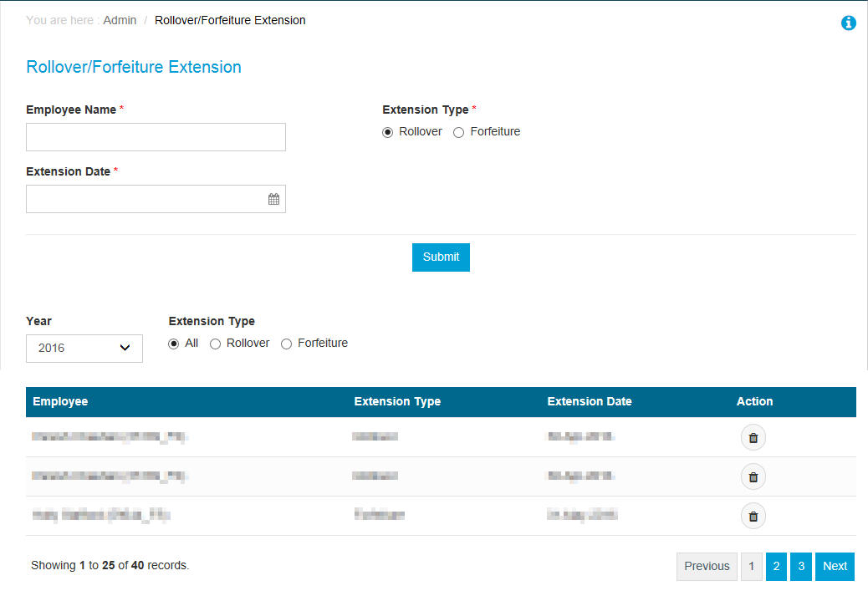

1. Rollover / Forfeiture as per Employee Handbook ‘*for all individuals except Vice-Presidents, Directors and Principals, up to one half of an individual's annual accrual amount will automatically roll over into the next calendar year. Unused vacation that exceeds one half of the individual's annual accrual amount will be forfeited, unless otherwise required by applicable law. Individuals have until April 30th of the year immediately following the year in which they accrued the unused vacation to use their vacation carryover balance*’
2. Rollover extension: Employees are allowed to extend the forfeit/lapse date to a future date.
   1. LMS will provide a screen to US-HR (Liz/Pete) to do entries for rollover extensions by selecting employee ID, and input the extension end date for this employee.
   2. US HR Admin will enter the rollover information for employees in LMS and extension will be applied in LMS.
3. Forfeiture should be done in the pay cycle immediately following the forfeiture date.

Business rules:

LMS should forfeit remaining rolled over vacation hours in May 1-15th pay cycle of each year. If an employee takes vacation in the last week of April, it should show as going against his/her rolled over balance in LMS (till April 30) instead of their current year’s accrued balance. Forfeiture for extension cases should cover the deadline extensions currently allowed (i.e. an employee with approval from Supervisor and HR can extend the deadline to take rolled over vacation to either 5/31 or 6/30). In these cases, the forfeiture should be done in the next pay cycle immediately following the deadline period. For example, if the forfeiture deadline is extended till June 30th, forfeiture should be done in the 1st pay cycle for July.

1. This feature would be available to user logged in with role as US HR Admin.
2. Following details to be available on screen:
   1. Employee Name 🡪 Mandatory Auto extender field, this would allow searching all FS active employees
   2. Extension Type 🡪 Mandatory radio button control, having options Rollover and Forfeiture
   3. Extension date 🡪 Mandatory Date/Time control.
   4. Submit 🡪 Button control
      1. On click of submit button, the record for forfeiture or rollover should be saved successfully.
      2. Validation on submit button
         1. If Extension type is not selected, then message to appear as ‘Please select Extension Type’
         2. If Employee Name not selected, then message to appear as ‘Please select valid employee’
         3. If employee name is not valid, then message to appear as ‘Please select valid employee’
         4. If Extension date is not selected, then message to appear as ‘Please select date’
         5. Extension date is of past years, then message to appear as ‘Extension date can of current year or following year’
         6. If Forfeiture Extension is done for an employee more than once with extension date being of the same year, then duplicate record error should come.
         7. If extension date is not of the same year, the system should accept the input.
   5. History section
      1. Year 🡪 dropdown field
         1. List would contain the years for which the rollover or forfeiture data available.
         2. Current year to be selected by default
      2. Extension Type 🡪 radio button control
         1. List to include options All, Rollover, Forfeiture
         2. All option to be selected by default
      3. Details table
         1. Employee 🡪 Employee details filtered as per the year and extension type selected, Name format : Employee Name (ID)
         2. Extension 🡪 Extension type filtered as per the year and extension type selected
         3. Extension Date 🡪 Extension date of the record filtered as per the year and extension type
         4. Action

🡪 Delete the record

On click of delete button the rollover or forfeiture record should be marked inactive or deleted.

### Admin >> Update Disability Schedule

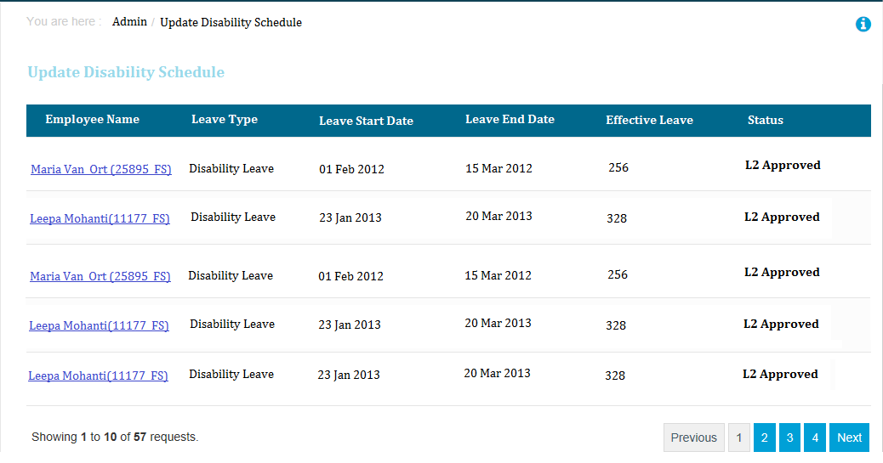

1. The Update Disability schedule form would be available to user with role US HR Admin
   1. following details to be displayed on screen
      1. Employee Name
      2. Leave Type
      3. Leave Start Date
      4. Leave End Date
      5. Effective Hours
      6. Leave Description
      7. Sick Leave Balance
      8. Personal Days Balance
      9. Vacation Leave Balance
      10. Uploaded Document
      11. Disability Leave bifurcation as per policy
2. First, any unused sick days are paid out at 100% starting from the day the Employee is deemed disabled.
3. For the first and second weeks of disability after sick days are used, the Employee is paid 100% of their base salary, provided they are deemed disabled according to Capgemini FS GBU’s disability advisor.
4. For the third and fourth weeks of disability, the Employee receives 80% of their base salary, provided they are deemed disabled according to Capgemini FS GBU’s disability advisor.
5. For the fifth week of disability through the remaining coverage period (180 calendar days maximum), the Employee receives 60% of their base salary, provided they are still disabled as determined by Capgemini FS GBU’s disability advisors.
6. Employees may use accrued vacation or personal time to supplement the unpaid periods of their disability leave of absence.
7. Table to contain following fields
   1. Sr No
   2. Start Date
   3. End Date
   4. Effective Days
   5. Percentage
   6. Personal
   7. Vacation
   8. Sick Leave
8. The disability leave should be divided in 5 days duration starting from the leave start date
9. First 5 days of the leave should be adjusted with the Sick Leave balance if available
   1. Percentage should be shown 100% and Sick Leave field should show True
10. Next 5 +5 days (2 records) would be the disability leave
    1. Percentage should be shown 100% (as the employee would be paid 100%) and Sick Leave field for both record would be false (as it is already adjusted)
11. Next 5 + 5 days (2 records) would be disability leave
    1. Percentage should be shown 80% (as the employee would be paid 80%) and Sick leave field both record should show false
    2. The Personal and Vacation record check box should be enabled
    3. Approver HR can adjust employees disability record with the available Personal Days and Vacation days
    4. They would do so by checking the check box against Personal days and Vacation days
    5. Once a duration record is checked for Vacation days and/or Personal days and the form is submitted, then the percentage should be updated to 100%
    6. Once a record which was earlier 80% and was marked to be adjusted with Vacation leave then the next 5 + 5 days should be marked as 80%
12. Remaining days until leave end date or until 180 days of disability leave
    1. Percentage should be shown 60% and sick leave field for the records would be false
    2. If Personal and Vacation record is already checked and adjusted then the check box would not be enabled for following records
    3. If Personal and Vacation record is not checked, then for all the remaining records the check box to be enabled to have the Personal and Vacation leaves adjusted with disability leave

### Admin >> ADP Schedule Payment

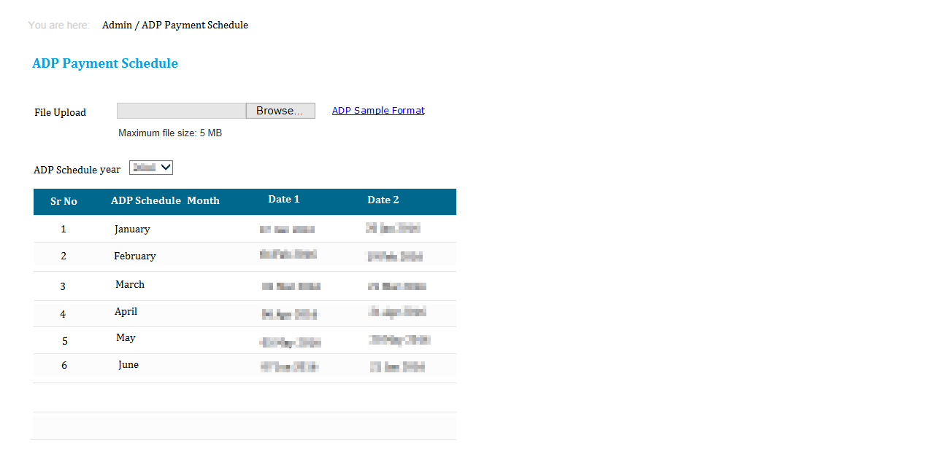

* This report to be available to users with Role ‘ADP Reports’
* Through this form user will upload dates on which leave credit should happen for US
* Following fields to be available on form
  + File Upload : Mandatory browse and upload control, allowing file upto 5mb
  + ADP Sample Format: link button directing to the file
  + ADP Schedule Year: dropdown field, list having all the years for which data is available
  + ADP Details table
    - Sr No
    - ADP Schedule Month
    - Date 1
    - Date 2
* When the file is uploaded, system should delete existing data if any for the year for which data is being uploaded.
* Once the file is successfully uploaded, appropriate message will be shown to user.
* While saving, it should be ensured that there are two dates available for each month.

### Admin >> Exception Offer

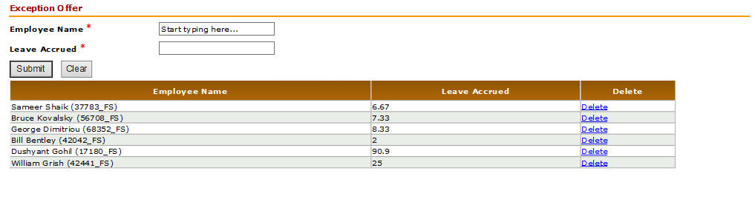

* This screen to be available to user with role US HR Admin
* This form would allow admin to update the exception offer applicable to employee.
* Following details to be available on form
  + Employee Name: mandatory auto extender control, allowing searching FS employee with location as US
  + Leave Accrued: mandatory text box control, 4 digit fractional numbers should be allowed in the text box
  + Submit: button control, on click of which, the leave accrued input should be saved for the selected employee
    - If an input is already available for an employee, then error should come as ‘Exception Offer input already available. Please remove the available input and re-enter updated details. ’
  + Exception Offer table
    - Employee Name (ID)
    - Leave Accrued
    - Action: Remove link to be available, to remove the leave accrual input provided for employee.
* The updated Leave accrual should be applicable to employee when the next accrual job runs.

### Reports >> View Holiday List

<Screenshot would be shared once final 🡪 aligned with India implementations>

1. Default HL is for logged in user’s current location HRMS.
2. Select year option available (from 2017 onwards). Default is current year.
3. User will be able to view current location HL on this screen.

### Reports >> Leave Details

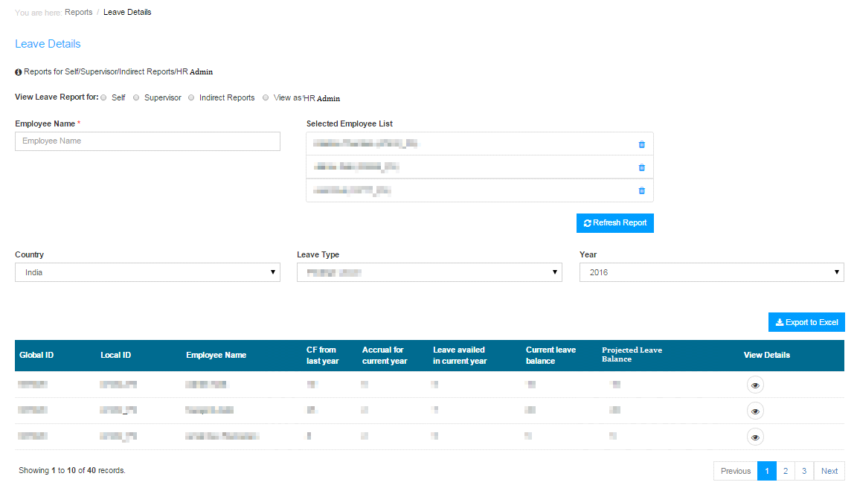

Display radio button for user to select required leave details view.

* “View leave details for” radio button options:
* Self - to view leave details only for self, available to L0, L1 and L2
* Supervisor - to view leave details for self and direct reports, available to L1 and L2 users
* Indirect Reports - to view leave details for indirect reports, available to L1 and L2 users
* HR Admin - allow L2 users to view leave details for selected employees

These radio buttons are available for selection based on user’s access level in LMS.

* If employee does not have direct and indirect reports, and is not HR Admin user, then only the Self radio button is available (default selection)
* If employee has direct reports, then Supervisor radio button is available for selection
* If user has indirect reports, then indirect reports radio button is available for selection
* If user is HR Admin user, the HR Admin radio button will be available for selection

On selection of HR Admin radio button,

* User will be able to search for employees in the employee field and add them one by one to the scrollable list box
* User can add up to 50 employees at a time to the scrollable list box
* Selected employees can be unselected using the delete option in the scrollable list box
* This section is hidden by default and is visible only if user has selected the HR Admin radio button

Dropdowns:

* Country - US default if US employee / supervisor / Admin has logged in
* Leave type - 10 leave types for US, Vacation leave default, and Holidays
* Year - from 2017 till current year, default current year

To see leave details for the selected employees/options, click on Refresh Report button.

Export to excel allows user to download the data displayed in the data grid section into excel file.

Leave data grid section:

* One record for each employee will appear in data grid for the selected leave
* If Self radio button is selected, only one record for logged in user will be displayed and this record can be exported to excel
* Clicking on EYE will open the Ledger screen with entire history for selected leave type in ledger format
* All transactions for each request including submitted, approved, rejected, cancelled, cancel approved, etc. for selected year will appear on the Ledger screen.
* Export to excel will save the ledger details to excel.

For employees to see the Holidays availed by them, we need data pull from clarity as employee does not apply for holiday in LMS.

Proposed solution without pulling Clarity holiday data is as follows:

1. For each employee, identify duration of each holiday mapped in selected year,
2. This duration should cover 365 days of selected year, or till today’s date if current year is selected (default)
3. Add the holidays for selected year, or till today’s date for current year
4. Holidays selection will show one row per employee on the Leave Details Report.
5. When user opens EYE (view details), the Holidays details should have complete transactions for each change of HL mapping on each row for each holiday availed in selected year, or till today for current year.
6. These records will be exported to excel as well.

Include BU/Entity and Country in grid and reports

Following fields will be displayed in leave data grid for Privilege Leave type

* Global ID
* Local ID
* Employee Name
* Carry forward from last year
* Leave lapsed for last year
* Leave accrual for year
* Leave availed in year
* Projected leave balance
* Leave balance
* Unit (whether leave is calculated in days or hours)
* Current BU (default FS for US employees)
* Current Country
* EYE for View details

Following fields will be displayed in leave data grid for “Holidays”

* Global ID
* Local ID
* Employee Name
* No. of times Holiday mapping changed in year
* Total no. of Holidays availed in year
* Unit
* Current BU
* Current Country
* EYE for View details

Note: In report (ledger details) provide details of all occurrences for all years available.

Following fields will be displayed in leave data grid for the remaining leave types

* Global ID
* Local ID
* Employee Name
* No. of occurrences in year
* Total days availed in year (add leave days for selected year)
* Unit
* Current BU (default FS for US employees)
* Current Country
* EYE for View details

Note: In report (ledger details) provide details of all occurrences for all years available.

Export to excel fields: 

Ledger screen will display following details, export will extract same data into excel:

Selected leave type requests to be extracted in the ledger report for the selected employee/s.

Include applicable BU/Entity and Country in grid and reports based on each duration for each record, sort actions for each request in ascending.

Refer attached: 

### Reports >> Unpaid Payroll Report For US

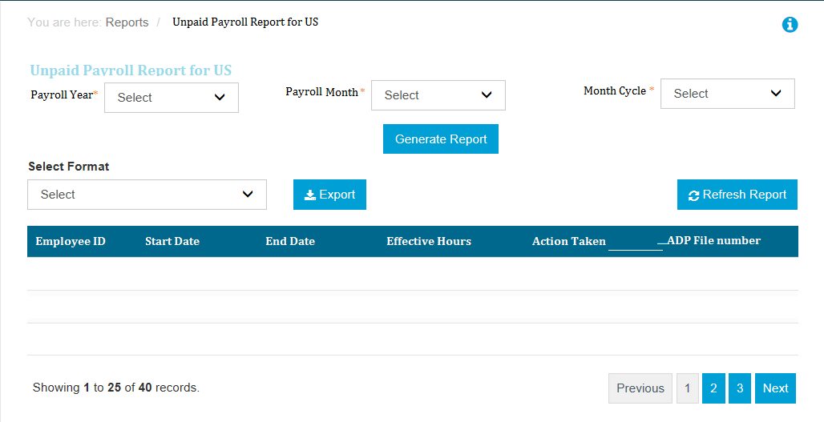

1. This report should be available only for the user with role ADP Reports
2. This report gives payroll details as per year month and bi-month cycle and details fetched in the report are Unpaid leave dates, action taken and ADP file number.
3. Report to have following details
   1. Payroll year 🡪 mandatory dropdown field
      1. The list to contain the years for which data is available
   2. Payroll month 🡪 mandatory dropdown field
      1. The list to contain the months for which the leave accrual is done based on the year selected
   3. Month cycle 🡪 mandatory dropdown field
      1. The list to contain ‘First half of the Month’ and ‘Second half of the Month’
      2. If for a selected month the accrual is not yet done for second half of the month then that would not be available in the dropdown
   4. Report fields
      1. Employee ID
      2. Start Date 🡪 Leave start date
      3. End Date 🡪 Leave end date
      4. Effective Hours 🡪 effective hours between start date and end date including the start hours and end hours.
      5. Action Taken 🡪 Action taken would be either ‘Deduct from Employee’ or ‘Refund to Employee’
      6. ADP File number
4. This is a batch wise report, which displays the unpaid leave information applied by employee between the cut-off of dates provided in ADP Schedule.

Current SP to refer: rpt\_UnpaidLeavePayrollReportForUS

All US employees will be considered for this report. Only employees who have been granted access to the “ADP Reports” role will be able to view this report. The format of this report is very specific to the US Payroll team and hence any changes to this report should be done only after their approval. The actual leave taken data is considered for this report. The leaves that are considered as unpaid leave are: Sabbatical Leave, Family Medical Leave of Absence (FMLA), Unpaid Personal Leave of Absence and Military Leave.

Following are the steps to be performed:

1. Based on the payroll year, month and semi-month selected, check whether there is a report already generated for the same or not. If not, then proceed with the next step. If yes, then show that report data directly.
2. Consider all employees who have taken / modified leave without pay in the month, year & semi-month for which the report is generated. However, the leave taken date should not be after the last day of the semi-month.
3. The cut-off dates for the semi-month are: 1st – 15th of the month for “First half of month” and 16th – end of month for “Second half of month”.
4. Out of this list, remove all those entries which have already appeared in the previous payroll reports.
5. Convert the remaining entries into continuous block of days.
6. Calculate the no. of hours = sum of no of hours for each date between the start and end dates.
7. If the employee has applied for leave, then the status should be “Deduct from employee”. If the leave is cancelled, then the status should be “Refund to employee”.
8. Once the report is completed, store the snapshot of the report.

### Reports >> Unpaid Disability Payroll Report For US

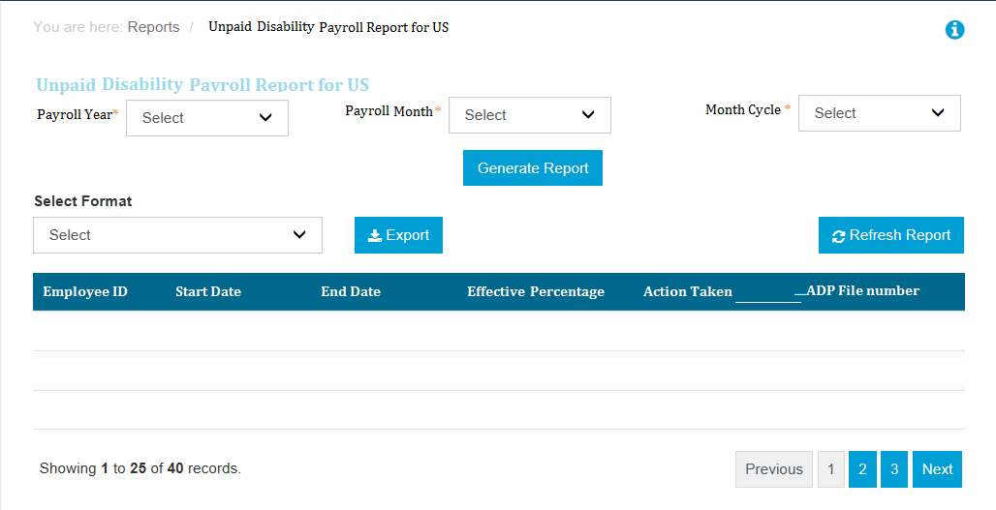

1. This report should be available only for the user with role ADP Reports
2. This report gives payroll details as per year month and bi-month cycle and details fetched in the report are Unpaid disability leave dates, action taken and ADP file number.
3. Report to have following details
   1. Payroll year 🡪 mandatory dropdown field
      1. The list to contain the years for which data is available
   2. Payroll month 🡪 mandatory dropdown field
      1. The list to contain the months for which the leave accrual is done based on the year selected
   3. Month cycle 🡪 mandatory dropdown field
      1. The list to contain ‘First half of the Month’ and ‘Second half of the Month’
      2. If for a selected month the accrual is not yet done for second half of the month then that would not be available in the dropdown
   4. Report fields
      1. Employee ID
      2. Start Date 🡪 Leave start date
      3. End Date 🡪 Leave end date
      4. Effective Hours 🡪 effective hours between start date and end date including the start hours and end hours.
      5. Action Taken 🡪 Action taken would be either ‘Deduct from Employee’ or ‘Refund to Employee’
      6. ADP File number
4. This is a batch wise report, which displays the unpaid disability leave information applied by employee between the cut-off of dates provided in ADP Schedule.

### Admin >> Role Management

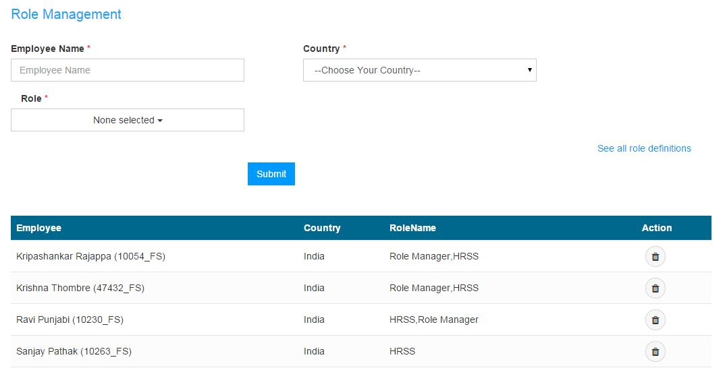

1. There are 3 roles for US
   1. Role Manager = Super user to grant and revoke LMS roles to employees
   2. US HR Admin = HR role to decision LMS requests that require HR verifications/approval
   3. ADP Admin = Admin to input ADP schedule and extract ADP reports
2. Only the Role Manager will have access to Role management screen to assign LMS roles.
3. Role Manager (RM) will select the Country
4. RM will enter required employee name and submit. Name of employee should be searchable along with GGID, Local\_Emp\_ID, NT\_user\_ID, First\_name, Last\_Name, etc.
5. Employee will be able to perform assigned role with immediate effect.
6. List of previously assigned roles (refer screen) is available, delete option allows Role Manager to delete previously assigned roles.
7. Deleting employee from the role management history section will delete all roles assigned to that employee with immediate effect.
8. The selected employee will get notification on role assigned or deleted, copy to RM.
9. List of assigned roles with details will be sorted by employee name.
10. Mail to be sent post role addition

|  |  |  |  |  |
| --- | --- | --- | --- | --- |
| From: <LMS system generated ID>  To: Employee  Cc: Role manager  Subject: Role assigned in LMS by <name of submitter>  Hi,  This is to inform you that the following role has been assigned to you in LMS with immediate effect.   |  |  | | --- | --- | | Role | Start Date | | <Role Name> | <Date> |   Note:   * Please login to [<URL for LMS>](https://lms.fs.capgemini.com) to access LMS application * For any technical/functional issues, kindly raise your service request using : [<Service desk portal](http://arserver.eu.capgemini.com:8080/arsys/forms/eu-itsm-prod.corp.capgemini.com/SRS:ServiceRequestConsole/?mode=submit&F303900000=4&F303900900=SRGAA5V0GKHD1AMQ7J0M1DP80F9286&F303906700=0&F303902000=0&F303902100=0)> (Employee Management >> Leave Management System).   Regards, <Role manager Name (employee ID)> |

Mail to be sent post role revoke

|  |  |  |  |  |
| --- | --- | --- | --- | --- |
| From: <LMS system generated mail ID>  To: Employee  Cc: Role manager  Subject: Role revoked in LMS by <submitter>  Hi,  This is to inform you that the following role has been revoked for you in LMS with immediate effect.   |  |  | | --- | --- | | Role | Revoked Date | | <Role Name> | <Date> |   Note:   * Please login to [<URL for LMS>](https://lms.fs.capgemini.com) to access LMS application * For any technical/functional issues, kindly raise your service request using : [<Service desk portal](http://arserver.eu.capgemini.com:8080/arsys/forms/eu-itsm-prod.corp.capgemini.com/SRS:ServiceRequestConsole/?mode=submit&F303900000=4&F303900900=SRGAA5V0GKHD1AMQ7J0M1DP80F9286&F303906700=0&F303902000=0&F303902100=0)> (Employee Management >> Leave Management System).   Regards, Role manager Name (employee ID) |

### Statuses maintained for US LMS 🡪(take confirmation)

|  |  |  |
| --- | --- | --- |
| **StatusName** | **StatusDescription** | **PendingStatusDescription** |
| Submit | Employee Submit | NULL |
| L1Approved | Approved by Supervisor | Pending US HR Admin Approval |
| L1Rejected | Rejected by Supervisor | NULL |
| L2Approved | Approved by US HR Admin | NULL |
| L2Rejected | Rejected by US HR Admin | NULL |
| Cancelled | Cancelled | NULL |
| L1Cancelled | Cancelled By Supervisor | NULL |
| L2Cancelled | Cancelled By US HR Admin | NULL |
| L1Submit | Submitted By Supervisor | NULL |
| L2Submit | Submitted By US HR Admin | NULL |

### Business Rules

* Eligible Employees accrue vacation on a semi-monthly basis.
* for all individuals except Vice-Presidents, Directors and Principals, up to one half of an individual's annual accrual amount will automatically roll over into the next calendar year
* Unused vacation that exceeds one half of the individual's annual accrual amount will be forfeited
* Individuals have until April 30th of the year immediately following the year in which they accrued the unused vacation to use their vacation carryover balance.
* Any prior year's balance that remains on April 30 will be forfeited
* Vice-Presidents and Principals will be able to roll over up to five days of accrued, unused vacation time.
* Unused vacation time that exceeds five days will be forfeited
* Vice-Presidents and Principals have until April 30 of the year immediately following the year in which they accrued the unused vacation to use their vacation carryover balance
* Any prior year's balance that remains on April 30 will need to be forfeited.
* Regular full-time Employees working a minimum of thirty (30) hours per week are eligible for two (2) personal days each year
* Personal days for the first calendar year of employment accrue according to the date of hire in US.
* Employee is entitled for 5 days Sick Leave at the start of the year.
* At the end of assignment in US or tenure with organization or end of year, the unused sick leave should get lapsed
* If an Employee is out of work due to illness for three (3) or more consecutive days, they may be required to attach doctor’s note in LMS.
* Disability leave duration should not be more that 180 days 🡪 Need to confirm
* First, any unused sick days are paid out at 100% starting from the day the Employee is deemed disabled.
* For the first and second weeks of disability after sick days are used, the Employee is paid 100% of their base salary, provided they are deemed disabled according to Capgemini FS SBU’s disability advisor.
* For the third and fourth weeks of disability, the Employee receives 80% of their base salary, provided they are deemed disabled according to Capgemini FS SBU’s disability advisor.
* For the fifth week of disability through the remaining coverage period (60 calendar days maximum for Short Term Disability - STD), the Employee receives 60% of their base salary, provided they are still disabled as determined by Capgemini FS SBU’s disability advisors
* After 60 days, Employee may be eligible for Long Term Disability (LTD) at 60% of base salary
* Employees may use accrued vacation or personal time to supplement the unpaid periods of their disability leave of absence.
* For Bereavement leave up to three (3) working days of leave with pay (not charged to other leave time) shall be granted to regular

# Screen Shots

|  |  |  |  |
| --- | --- | --- | --- |
| **Requirement Reference** | **Source of the screen** | **Destination of screen** | **Remarks** |
|  |  |  |  |

# Field Validation

List down the field level validations in the following table:

|  |  |  |  |  |
| --- | --- | --- | --- | --- |
| **Field** | **Label** | **Property ( Type, Size/ Length)** | **Message (in case of failure)** | **Remarks** |
|  |  |  |  |  |

# Cross Field Validation

List down the field level cross validations in the following table:

|  |  |  |  |
| --- | --- | --- | --- |
| **Field** | **Cross field** | **Message (in case of failure)** | **Remarks** |
|  |  |  |  |

# Messages

List down the various messages which might be required at various stages of the navigation

|  |  |  |  |
| --- | --- | --- | --- |
|  |  |  |  |

## 